**ABSRACT**

Image splicing also known as photo montage is a type of image forgery that involves compositing or combining two or more different images to create a fake image. Image splicing detection techniques have been developed to ensure whether the image content is modified after it was acquired. Image splicing detection would have huge impact in various application domains such as, crime investigation and detection, fashion industry, scientific journals, insurance claim processing, law enforcement, medical imaging, surveillance system and many others.

In this research work importance of digital image splicing detection and its implementation issues have been discussed. This method has lower computational complexity and high accuracy rate over the existing methods but not suitable for spatial feature based analysis. Hence, a new optimized wavelet based algorithm has been implemented with reduced multi dimensional scaling features to discover the spliced image regions which are blurred, brightness altered and colour reduced with different levels. Wavelet based method is inappropriate when the spliced region is rotated or scaled. Hence, as part of this research work, moment invariant based splicing detection method has been developed based on LBP and HOG features using GARIC algoriyhm. An efficient splicing detection algorithm has been developed based on ANN to discover simple and multiple spliced regions even after some geometric and image distortions. Results show that this method performs better than existing SIFT and SURF methods. Selection of optimum features from the extracted features is another significant phase in any splicing detection approach.

**INDEX**

**CHAPTER NO** **PAGE NO**

**LIST OF FIGURES**

|  |  |  |  |  |  |  |  |
| --- | --- | --- | --- | --- | --- | --- | --- |
| **CHAPTER1:** | | | | | **1-31** | | |
| **1. INTRODUCTION** | | | | |  | | |
| 1.1 Introduction | | | | | 1 | | |
| 1.2 | | Digital images | | | **2-4** | | |
|  | | 1.2.1 | Image acquisition | | 2 | | |
|  | | 1.2.2 | Image coding | | 3 | | |
|  | | 1.2.3 | Image Editing | | 4 | | |
| 1.3 | | Importance of splicing detection | | | 4 | | |
| 1.4 | | General architecture | | | 4 | | |
| 1.5 | | Analyzing Intrusive and Non-Intrusive | | | splicing detection | | |
|  | | methods and its challenges | | | 4 | | |
| 1.6 | | Intrusive techniques | | | **5-8** | | |
|  | | 1.6.1 | Digital watermarking | | 5 | | |
|  | | 1.6.2 | Digital signature | | 7 | | |
| 1.7 | | Non-Intrusive techniques | | | **8-13** | | |
|  | | 1.7.1 | Image source identification | | 8 | | |
|  | | 1.7.2 | Image splicing detection | | **9-13** | | |
|  | |  | 1.7.2.1 Copy move | | 11 | | |
|  | |  | 1.7.2.2 Image splicing | | 12 | | |
|  | |  | 1.7.2.3 Image Retouching | | 13 | | |
| 1.8 Splicing detection by checking image manipulation | | | | | 26 |
| 1.8.1 Block based approaches | | | | | **28-31** |
|  | | | 1.8.1.1 Frequency transformation based methods | | 28 |
|  | | | 1.8.1.2 Dimension reduction methods | | 29 |
|  | | | 1.8.1.3 Moment based Methods | | 30 |
| 1.8.2 Key point based approaches | | | | | 31 |
| 1.9 Implementation issues in existing image splicing detection | | | | |  |
| Techniques | | | | | 31 |

|  |  |  |  |
| --- | --- | --- | --- |
| **CHAPTER 2:** | | |  |
| **2. LITERATURE SURVEY** | | | **32-40** |
| 2.1 Introduction | | | 32 |
| 2.2 | Image manipulations | | 32 |
| 2.3 | Image forgery detection | | **33-34** |
|  | 2.3.1 | Active Approaches | 33 |
|  | 2.3.2 | Passive Approaches | 33 |
| 2.4 Image splice detection in images | | | 34-35 |
|  | 2.4.1 Block Based Methods | | 35-40 |

|  |  |  |
| --- | --- | --- |
| **CHAPTER 3:** | |  |
| **3. EXISTING METHOD** | | **41-46** |
| 3.1 | Introduction | 41 |
| 3.2 Role of transformation in splicing detection | | **41-43** |
|  | 3.2.1 Fourier transform | 41 |
|  | 3.2.1.1 Discrete Fourier transform (DFT) | 42 |
|  | 3.2.2 Walsh transform | 43 |
|  | 3.2.3 The Hadamard transform | 44 |
|  | 3.2.4 The Haar transform | 45 |
|  | 3.2.5 The slant transform | 45 |
|  | 3.2.6 Karhunen loeve (kl) or hotelling transform | 45 |
| 3.3 Discrete Cosine Transform (DCT) | | 46 |
| 3.4 DCT Based splicing Detection using sub block approach | | 47-50 |
| **CHAPTER 4:** | |  |
| **4. ANN-CLASSIFICATION** | | **51-65** |
| 4.1 | Reason for selecting Artificial Neural Networks | 51 |
| 4.2 | Working principles | 51 |
| 4.3 | Delta Learning Rule | 52 |
| 4.4 | Single Layer Artificial Neural Network Classifier | 52 |
| 4.5 | Classification using Single Layer Artificial Neural Network |  |
|  | Classifier | 53 |
| 4.6. Multi-Layer Artificial Neural Network | | **54-56** |
|  | 4.6.1 Back Propagation Algorithm | 55 |
|  | 4.6.2. Steps performed in Back propagation Algorithm | 55 |
|  | 4.6.3 Informal Description of Back Propagation Algorithm | 55 |
| 4.7 | Optimized Multilayer with Back Propagation Algorithm |  |
|  | (OMLBPNN) | 56 |
|  | 4.7.1. Basic Structure | 59 |
| 4.8 | Learning Rule | 62 |
|  | 4.8.1. Supervised Learning Approach | 62 |

|  |  |  |
| --- | --- | --- |
| 4.8.2. Unsupervised Learning Approach | 62-63 | |
| 4.9 Feed-Forward Neural Network | 63 | |
| 4.10 Feed Backward Neural Networks | 63-65 | |
| **CHAPTER 5:** | |  | |
| **PROPOSED METHOD** | | **66-74** | |
| **CHAPTER 6:** | |  | |
| **ABOUT PYTHON SOFTWARE** | | **75-81** | |
| **CHAPTER 7:** | |  | |
| **RESULTS AND ANALYSIS** | | **82-83** | |
| **CHAPTER 8:** | |  | |
| **CONCLUSION AND FUTURE SCOPE** | | **84-85** | |
| **REFERENCES** | | **86-88** | |

**LIST OF FIGURES**

|  |  |  |  |  |  |  |  |
| --- | --- | --- | --- | --- | --- | --- | --- |
| **Fig.NO** | | | **NAME OF THE FIGURE** | | **PAGE NO** | | |
|  | | |  | |  | | |
| 1.1 | | | Examples of image splicing throughout History | | 2 | | |
|  | | |  | |  | | |
| 1.2 | | | The Life cycle of Digital Image | | 3 | | |
|  | | |  | |  | | |
| 1.3 | | | various stages in coding phase | | 3 | | |
|  | | |  | |  | | |
| 1.4 | | | Architecture of image splicing detection | | 4 | | |
|  | | |  | |  | | |
| 1.5 | | | Classifications of image splicing detection techniques | | 5 | | |
|  | | |  | |  | | |
| 1.6 | | | Watermark embedding and extraction process | | 6 | | |
|  | | |  | |  | | |
| 1.7 | | | (a) Image with visible watermark (b) Image with invisible watermark | | 6 | | |
|  | | |  | |  | | |
| 1.8 | | | Watermark design for splicing detection | | 7 | | |
|  | | |  | |  | | |
| 1.9 | | | Various steps involved in the creation of digital signature | | 8 | | |
|  | | |  | |  | | |
| 1.10 | | | Overview of non-intrusive image source identification problem | | 9 | | |
|  | | |  | |  | | |
| 1.11 | | | A framework of image splicing creation process | | 10 | | |
|  | | |  | |  | | |
| 1.12 | | | Steps involved in passive image splicing detection process | | 10 | | |
|  | | |  | |  | | |
| 1.13 | | | Example for copy-move splicing (a) and (c) are original images, (b) and | | 11 | | |
|  | | | (d) are spliced images | |  | | |
|  | | |  | |  | | |
| 1.14 | | | Steps involved in image splicing | | 12 | | |
|  | | |  | |  | | |
| 1.15 | | | Example for image splicing (a),(b),(d),(e) are original images, (c) and (f) | | 12 | | |
|  | | | are spliced images | |  | | |
|  | | |  | |  | | |
| 1.16 | | | Example for image retouching (a) and (c) are original images, (b) and (d) | | 13 | | |
|  | | | are retouched images | |  | | |
|  | | |  | |  | | |
| 1.17 | | A Framework for splicing detection based on image manipulation | | 13 | | |
|  | |  | |  | | |
| 3.1 | | Frame work of proposed splicing detection algorithm | | 47 | | |
|  | |  | |  | | |
| 3.2 | | Pixel block scan and matrix representation of proposed algorithm | | 48 | | |
|  | |  | |  | | |
| 3.3 | | Flowchart of lexicographical sorting | | 49 | | |
|  | |  | |  | | |
| 4.1 | | Tan h learning function | | 54 | | |
|  | |  | |  | | |
| 4.2 | | Structure of Optimized Multi Layer Back Propagation Neural Network | | 57 | | |
|  | |  | |  | | |
| 4.3 | | Modeling of Artificial Neural Networks | | 60 | | |
|  | |  | |  | | |
| 4.4a | | (a) Hard Limiter | | 60 | | |
|  | |  | |  | | |
| 4.4b | | (b)Linear Function | | 61 | | |
|  | |  | |  | | |
| 4.4c | | (c) Radial Basis Function | | 61 | | |
|  | |  | |  | | |
| 4.4d | | (d) Sigmoid Function | | 62 | | |
|  | |  | |  | | |
| 4.5 | | Feed-Forward Neural Networks | | 63 | | |
|  | |  | |  | | |
| 4.5 | | Back Propagation Neural Networks | | 64 | | |
|  | |  | |  | | |
| 5.1 | | The overall research framework of the splicing image forgery | | 67 | | |
|  | | identification | |  | | |
|  | |  | |  | | |
| 5.2 | | The multi-scale LBP operator | | 68 | | |
|  | |  | |  | | |
| 5.3 | | Splicing Image Forgery feature extraction process and object | | | 71 | |
|  | | identification procedure | | |  | |
|  | |  | | |  | |
| 5.4 | | The workflow of the feature-level fusion | | | 73 | |
|  | |  | | |  | |
| 5.5 | | Framework to identify the spliced image using the majority voting | | | 73 | |
|  | |  | | |  | |
| 7.1 | | Spliced images and detected images | | | 82 | |
|  | |  | | |  | |
| 7.2 | | (a) original image, (b) Tampered image, (c) detection of tampered region. | | | 82 | |
|  | |  | | |  | |
| 7.3 | | (a),(b) are original images, (c) tampered image, (d) detection of tampered region. | | | 83 | |
|  | |  | | |  | |
| 7.4 | | An image splicing sample from two source images with distinct ISO | | | 83 | |
|  | | settings. a, b two source images from the BOSS raw database, (c) the  spliced image, (d) detection results with the proposed method | | |  | |





**CHAPTER 1**

**INTRODUCTION**

**1.1 Introduction**

Human visual system perceives the pictorial information faster than any other kind of information. According to biologists, 75 percentage of information perceived by the human brain is by visual activity. Images are generally used as major source of information for effective communication. An extended application based on the images includes security and authentication. However, the reliability of image is questionable due to the powerful and low cost image editing technologies which facilitate to acquire and manipulate digital images. These technological advancements laid a path to the researchers for analyzing splicedistics of images in image centric applications. Two primary questions need to be addressed by these researchers:

1. Whether the images are original or manipulated
2. Whether images captured using acquisition devices or fabricated images

To answer these questions image source identification and digital image splicing detection techniques got important in digital image world. Image source identification is an interesting research even for identifying devices which is used to capture the image in order to discriminate the image is acquired using a digital device or it is a computer generated images. Forensics analysis of digital image contents is a new field of research which facilitates to ensure the authenticity of digital images. Figure 1 is an example of images related to splicing analysis in this research work.

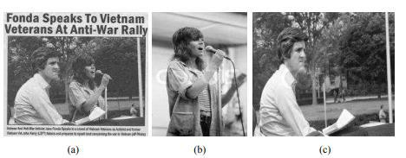



|  |  |
| --- | --- |
|  |  |

1





Figure 1.1 US Senator John Kerry and film actress Jane Fonda talked together in an Anti-Vietnam gathering by compositing their images (b) and (c) Images at two different places in 1971 and 1972.

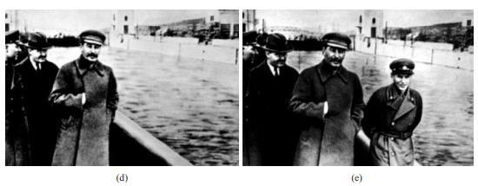

1. A commissar (Minister) was removed from the original photograph (e) After falling out

of favour with Stalin.

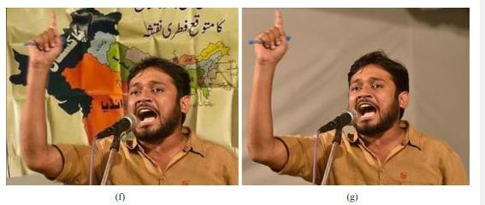

Figure 1.1 Student leader speaking in front of a map showing a divided India, in which portions of Kashmir and Gujarat were merged to Pakistan but in the original image (g) he is speaking in front of a blank background

Figure 1.1: Examples of image splicing throughout History **1.2 Digital images**

Digital images composed of finite number of elements called pixels. Each element has specific location and value. Life cycle of digital image is categorized in to three phases such as image acquisition, image coding and editing as shown in figure 2.

**1.2.1 Image acquisition**

Image acquisition is performed with the help of digital cameras, digital scanners and other handheld devices. Sensors in digital cameras gather the light coming from real scene





|  |  |
| --- | --- |
|  |  |

2





and convert it to electric impulses and these electric impulses consist of actual information about

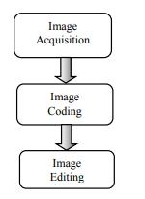

Figure 1.2: The Life cycle of Digital Image

the image. Each light sensitive part in the sensor will determine brightness of an image. The thin film in the sensor will allow only one colour component at a time but each pixels in an image will be a combination of three colours such as red, green and blue. Sensor output is successfully interpolated to make each pixel with a combination of all three colours through demos icing or Colour Filter Array (CFA) interpolation method. In order to obtain the digital colour image, the interpolated signals undergo camera processing operations such as, white balancing, colour processing, image sharpening, contrast enhancement and gamma correction.

**1.2.2 Image coding**



Figure 1.3: various stages in coding phase

Image coding is employed to store the acquired image in the camera memory. After image acquisition, the processed signal is stored in to camera memory with the help of image coding. Lossy image compression is most commonly used coding standard to store and transmit the image without substantial degradation in visual quality. In reality, most of the digital cameras automatically compress the image after acquiring it. Figure 1.3 illustrate various steps in image coding phase. The raw image data is supplied as an input to mapper





|  |  |
| --- | --- |
|  |  |

3





that transform the raw data in to a format designed to reduce spatial and temporal redundancy. Quantizer will keep the irrelevant information out of the compressed representation. Coder generates fixed or variable length code to represent the quantizer output and maps the output in accordance with the code.

**1.2.3 Image Editing**

The content of an image is enhanced or modified in image editing phase. Manipulated image content is post processed with some geometric transformation (Translation, scaling or rotation) and image distortion (blurring, brightness change, and contrast adjustment) to conceal the traces of editing.

**1.3 Importance of splicing detection**

According to Wall Street Journal, 10% of colour images published in the United States are altered or retouched. Unlike analogue images, digital images are easily manipulated with the rapid evolution of low cost and dominant image editing tools and techniques. Spliced images will destroy some ones reputation in the society and cause serious threats in image security. Hence, image splicing detection is essential for applications where it is used as an official document or evidence .

Image splicing detection techniques have been developed to ensure whether the image content is modified after it was acquired. Image splicing detection would have huge impact in various application domains such as, crime investigation and detection, fashion industry, scientific journals, insurance claim processing, law enforcement, medical imaging, surveillance system and many others.

**1.4 General architecture**

Different techniques have been developed to determine the processing history of an image and discover spliced regions in an image. The general architecture of image splicing detection technique is shown in figure 1.4.

**1.5 Analyzing Intrusive and Non-Intrusive** **splicing detection methods and its**

**challenges**





|  |  |
| --- | --- |
|  |  |
|  |  |

4

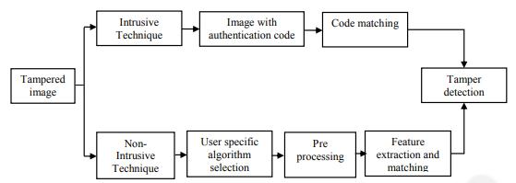



Figure 1.4: Architecture of image splicing detection

Nonintrusive techniques do not require prior knowledge about the image rather it makes use of user specific algorithm to detect the spliced image. Different methods are used in nonintrusive splicing detection where the size and type of the image features used to matching an image blocks or features will get vary. The successes of these methods are limited owing to the accuracy, time and false detection rate. Classification of image splicing detection techniques are shown in figure 1.5.

**1.6 Intrusive techniques**

**1.6.1 Digital watermarking**

Digital watermarking is a procedure for embedding authentication code in to an image through an imperceptible way without degrading the quality of image content. When the digital content is exchanged over the internet, it is necessary to check the copy-right and content authentication contravention issues. Design of watermarking may be based on a pattern, a logo, or an image. In general, water marking technique involves two phases such as code embedding and code extraction as shown in figure 1.6.

The given watermark W is inserted into original cover image I with the help of secret key K and watermark embedding function f. The watermarked image WI is generated as follows,

WI = f(W, K, I) (1)





|  |  |
| --- | --- |
|  |  |

5

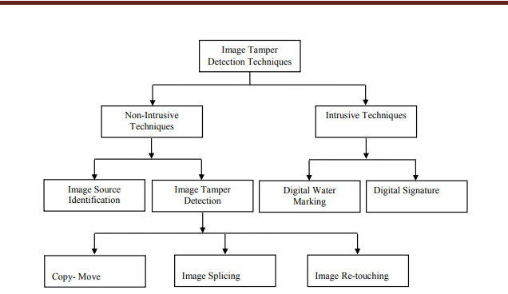

Figure 1.5: Classifications of image splicing detection techniques

Watermarked image WI is now ready to transmit over the communication channel. If any kind of modification happens in the content it produce the altered version of image I'. The extraction process is as follows,

=( ,I',K)(2)

where, EWI is a recovered image, E is an extraction process, W represent watermark, I' is altered version of image, K is a secret key known by sender and receiver. and proof of ownership, copyright management, content protection, and content authentication .

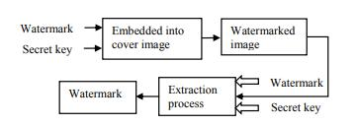

Figure 1.6: Watermark embedding and extraction process

The authentication code might be visible or invisible as shown in figure 1.7. Impact of digital watermarking has higher influence in many applications such as, authentication and splicing proofing, transaction tracking, broadcast monitoring, usage control, owner identity



|  |  |
| --- | --- |
|  |  |

6

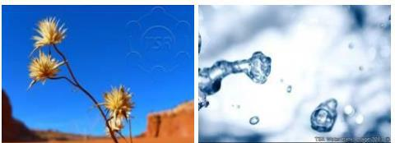

Figure 1.7: (a) Image with visible watermark (b) Image with invisible watermark Digital watermarking requires prior knowledge about an image and it cause damage to sensitive information present in the cover work. Watermarking cannot be used to detect the exact spliced region in an image. Watermarks may be destroyed when the images are compressed using compression algorithm. The architecture of digital watermarking based image splicing detection is shown in figure 1.8.

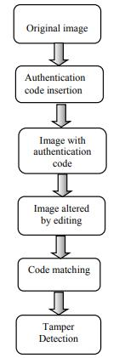

Figure 1.8: Watermark design for splicing detection **1.6.2 Digital signature**

Digital signature is another important intrusive technique used to validate digital information’s such as documents, images and e-mails. It makes use of encryption techniques for authentication and facilitates to ascertain the following.



|  |  |
| --- | --- |
|  |  |
|  |  |

7





* Recognize the owner of a document and verifies the information which is coming from the trusted source.
* Ensure that the content of digital information has not been modified.
* Used to authenticate the identity of sender and receiver and

includes automatic

dateand time stamp to increase the speed and accuracy of transaction.

Various steps involved in creation of digital signature are shown in the figure 1.9.

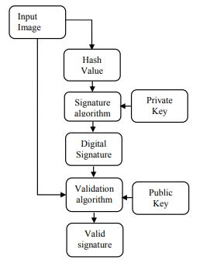

Figure 1.9: Various steps involved in the creation of digital signature

Though number of advantages in digital signature, there are certain limitations which includes user has to remember the encryption keys while checking reliability of information, It is not easy to develop single standards for wide user base, It is also difficult to get certificates from authorities and buying verification software.

**1.7 Non-Intrusive techniques**

Unlike intrusive techniques, non-intrusive techniques are not depending on any authentication code or explicit knowledge of the image. The two foremost functions of nonintrusive or blind image forensics detection are,

1. Image source identification
2. Image splicing detection

**1.7.1 Image source identification**

Digital images are produced with different devices such as digital camera, medical imaging devices, digital scanners, mobile phones and so on. Moreover, images are also generated with computer graphics techniques. The major objective of non-intrusive source identification is to



|  |  |
| --- | --- |
|  |  |

8



classify the image as photographic or photorealistic computer graphics image. Overview of non-intrusive image source identification problem is shown in figure 1.10.

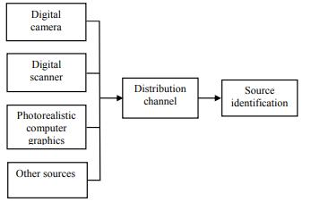

Figure 1.10: Overview of non-intrusive image source identification problem Classification of image source facilitates to decide whether an image is acceptable for a specific application or not. For example, a computer graphic image is absolutely not accepted for news reporting and other applications where images are used as evidence or official documents.

**1.7.2 Image splicing detection**

Non-intrusive splicing detection techniques are employed to address different types of image splicing called copy-move, image splicing and image retouching. Even though there are many techniques and algorithms used to discover the spliced image, there is no unique

and robust method to ensure the trustworthiness of an image. Splicing techniques are normally done to conceal and duplicate the objects in an image or composite two or more image fragment to produce false proof or to make the image looking better. In general, image splicing creation process involves three steps such as (1) splicing creation (2) appropriate intermediate operations and (3) Enforce some post processing operations. In splicing creation step, the common splicing methods like copy-move, image splicing or image retouching operations are involved. Intermediate operations such as translation, rotation, scaling and some post processing operations called noise addition, blurring, and JPEG compression are applied in the spliced image in order to hide the traces of splicing . Common framework for image splicing creation process is shown in figure 1.11. Various steps involved in non-intrusive or passive image splicing detection is shown in figure 1.12.





|  |  |
| --- | --- |
|  |  |

9

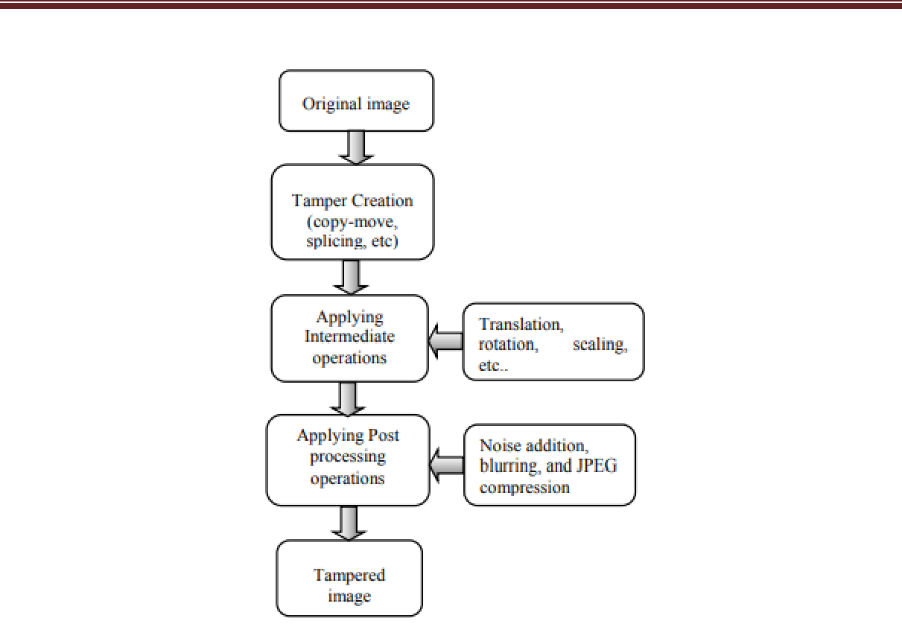

Figure 1.11: A framework of image splicing creation process

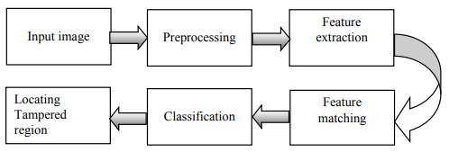

Figure 1.12: Steps involved in passive image splicing detection process

**Step 1: Input image**

Input image obtained from the distribution channel or any other sources is subject to check the trustworthiness.

**Step: 2 Pre-processing**

Pre processing is lower level of image processing technique in which both input and output are images. It is used to recover some degradation in an image. Real world images come in different sizes, converting these images into a particular format or type requires pre-processing operations. To improve the classification performance some pre-processing





|  |  |
| --- | --- |
|  |  |

10





operations such as transforming RGB to gray scale image, noise reduction operations are performed.

**Step: 3 Selection of user specific algorithm**

User specific algorithms are used to extract and match the selected image features to locate the spliced region without any predefined code or signature.

**Step: 4 Feature Extraction and matching**

Feature extraction helps to discriminate selected feature with constructed feature of the image. It will decrease computational overhead in training and classification. Feature matching helps to match the extracted features with similar behaviour.

**Step 5: Classification**

Classification is a task to determine the image is authentic or spliced. Different algorithms and classifiers are used to discriminate spliced image region from the original.

**1.7.2.1 Copy move**

Copy-move is most commonly used splicing technique in which part of an image is copied and pasted in the different part of same image in order to hide or duplicate certain part of an image. Uniform or texture regions are suitable part for image splicing since it has same colour, dynamic range and noise variation properties. Figure 1.13 is an example for copy move splicing.

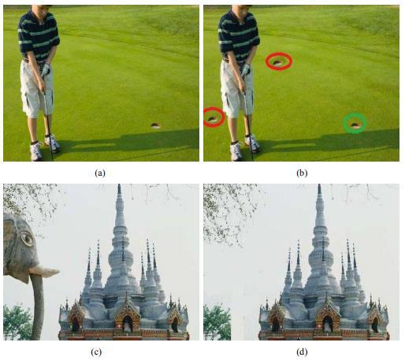

Figure 1.13: Example for copy-move splicing (a) and (c) are original images, (b) and (d) are spliced images





|  |  |
| --- | --- |
|  |  |

11



**1.7.2.2 Image splicing**

Image splicing or photomontage is another significant and often used image manipulation technique in which two or more image fragments are composited together to form a spliced image. Various steps involved in image splicing are shown in figure 14. Where SI(x, y) and TI(x, y) are original images, GI(x, y) is a part of SI(x, y) which is overlaid into TI(x, y) to generate a spliced image SP(x, y).

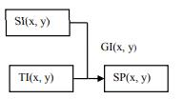

Figure 1.14: Steps involved in image splicing

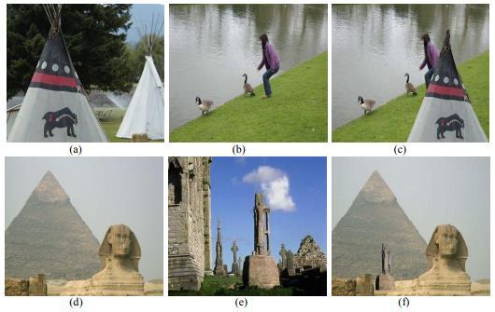

Figure 1.15: Example for image splicing (a), (b), (d), (e) are original images, (c) and (f) are spliced images

Background pixels around the overlaid image region are removed and pixel around the edge of the overlaid image region is retouched to match with original image. Figure 1.15 is an example for image splicing manipulation.





|  |  |
| --- | --- |
|  |  |

12





**1.7.2.3 Image Retouching**

Image re-touching is another category of image splicing method which is often used in harmless manner. It will increase or decrease certain features of an image rather than altering the image content. This technique is popular among magazine editors. Figure 1.16 shows original and re-touched image.

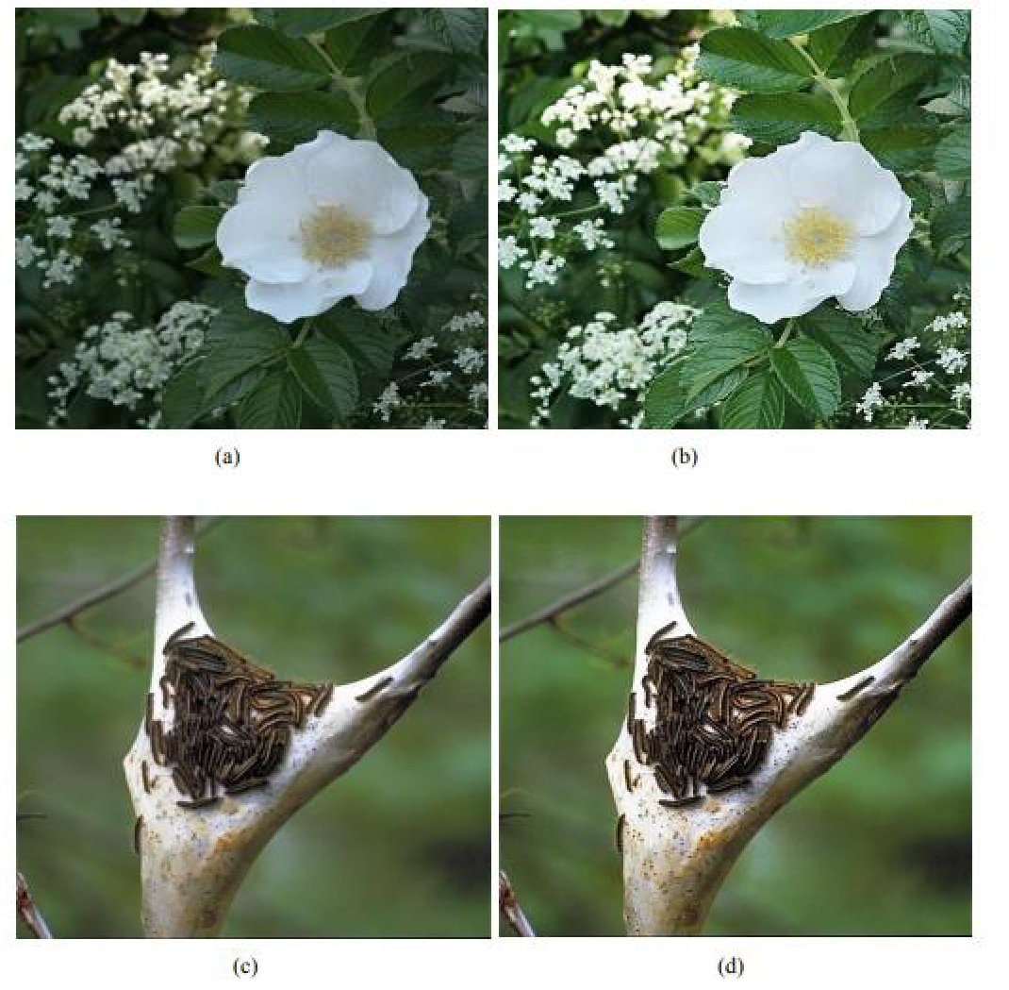

Figure 1.16: Example for image retouching (a) and (c) are original images, (b) and (d) are

retouched images

**1.8 Splicing detection by checking image manipulation**

Digital images are manipulated in different ways such as copy the part of an image and paste it in another part of the same image, combining two or more image fragments to form a composite image and increasing or diminishing certain features of an image without changing its content. These manipulations are performed to hide certain information, misrepresent text information in an image and create a false belief in the image.

Two types of approaches are used to detect the image manipulation based splicing such as block based and key point based approaches. In block based approaches the image is divided in to overlapping or non-overlapping blocks rather than detecting the key points. The process of detecting spliced image involves various steps like pre-processing, key point detection or block dividing, feature extraction, feature matching, filtering and verification as shown in figure 1.17.

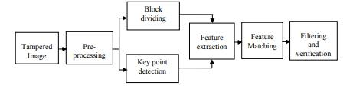

Figure 1.17: A Framework for splicing detection based on image manipulation

**a) Pre-processing**

Pre-processing step is common to both block and key point based approaches. To improve the splicing detection performance, some pre-processing operations like gray scale conversion, noise reduction, cropping and resizing operations are performed.

**b) Key point detection or block dividing**

Key points are detected in the image region with high entropy. In block based approach, the suspected image is alienated into overlapping or non- overlapping blocks rather than detecting key points.

**c) Feature extraction**

Features are small point of interest with variations in two dimensions. It arises due to geometric discontinuities and small patches of texture, for example points, edges and blobs are some of the image features. The image transformation techniques such as Discrete Cosine Transform (DCT), Discrete Wavelength Transform (DWT), Principle Component Analysis (PCA) and various key point descriptors are used to extract the features. Block dividing Pre-processing spliced Image Filtering and verification Feature Matching Feature extraction Key point detection.

**d) Feature matching**

Feature matching is performed to match the selected features with similar behaviour, block based approaches uses lexicographical sorting, radix sort and Counting Bloom Filters to match the features. Blocks having similar features are arranged in the adjacent rows of a matrix to detect the duplicate blocks. The key-point based methods utilize KD-tree algorithm, Best-Bin-First (BBF) search method and Euclidean distance to acquire the efficient nearest neighbour. KD-tree algorithm will give a better result than the lexicographical sorting but the





|  |  |
| --- | --- |
|  |  |

14





memory requirement is high. In addition to the above methods machine learning algorithms are used to classify the image is authentic or spliced.

**e) Filtering and verification**

Filtering process is applied to remove false matches, for example, neighbouring pixels having similar intensities and uniform or flat areas of the image will produce false matches. Different distance measures such as Euclidean distance, City Block distance, Quasi Euclidean distance and Random Sample Consensus (RANSAC) algorithms are used to filter the false matches. Correlation coefficients are used as a similarity criterion between two feature vectors. The verification process is used to ensure the given image is authentic or spliced by checking the features with similar behaviour.

**1.8.1 Block based approaches**

In block based approach, to reduce the complexity of splicing detection the suspected image is divided into overlapping blocks of specified size b. The total number of blocks should be (M-b+1) X (N-b+1) Where M and N are the number of rows and columns in an image. The feature vector is extracted from each block and matched its nearest neighbour to detect the spliced region [61].

**1.8.1.1 Frequency transformation based methods**

The frequency transformation coefficients are used as a feature descriptor to detect the splicing. It will reduce the size of the feature vector and robust against the post-processing operations such as additive noise and JPEG compression. This method is inadequate for the spliced image with some geometric distortions.

Fridrich et al. proposed the first method based on Discrete Cosine Transformation (DCT) to detect a special type of splicing called copy-move. Suspected spliced image is divided into overlapping blocks of fixed size and DCT transformation is applied to each block. DCT co-efficient are quantized and lexicographically sorted to effectively match the similar blocks. This method has higher computational complexity and produce false matches in the uniform and flat areas of the image.

Zhouchen et al. used an automatic splicing detection method that discover spliced JPEG images by investigating the double quantization effect concealed along with the Discrete Cosine Transform (DCT) co-efficient. This method is efficient even when the spliced region is post-processed by various methods such as in-painting, texture synthesis and alpha matting. Comparing with existing methods accuracy of this method is low and fails to detect some spliced image.





|  |  |
| --- | --- |
|  |  |

15





|  |  |
| --- | --- |
| Bashar et al. introduced a method to detect the | spliced region by means of Discrete |
| Wavelet Transformation (DWT) and Kernel Principal Component Analysis (KPCA) method. | |
| The coefficients of two transformations are lexicographically ordered to match the similar | |
| blocks. The wavelet-based methods produce good result than KPCA-based method in the | |
| noise-free and uncompressed image regions in terms of accuracy and false detection rate. The | |
| KPCA-based method performs better in the presence | of additive noise and lossy JPEG |

compression.

Ghulam et al. used un-Decimated dyadic Wavelet Transformation (DyWT) to detect copy move splicing. DyWT is shift-invariant and does not include down-sampling. The suspected input image is divided into low frequency (LL) and high frequency (HH) sub bands and LL sub band is divided in to overlapping sub blocks. The Euclidean distance between every pair of block is calculated and lexicographically ordered to match the similar blocks. This method is inappropriate for the spliced image with geometric transformation.

Bravo et al. proposed a method based on Log polar transformation, it is achieved by mapping the Cartesian space coordinates in to a radius(r) and angle θ (theta) relative to the origin of the coordinate system. It is used to reduce the size of the feature vector that is used in block matching phase and suitable to detect the spliced region which is rotated, scaled

and translated. However, the method is not appropriate for spliced image which is

.Contaminated by additive noise, blurring and JPEG compression. Log-polar transformation algorithm is more complicated than DCT based algorithms.

Qiumin et al. employed a technique that uses Log-Polar Fast Fourier Transform (LPFFT) on image blocks to approximate the Log-Polar Fourier Transformation (LPFT). The extracted features are well organized to fit in to computer memory to ensure optimum feature extraction. To compute discrete Fourier transform for all the blocks of an image leads high computational complexity.

Bravo et al. make use of log polar coordinates to map with overlapping blocks of pixels and summed along the angle axis to produce one-dimensional (1-D) descriptor. The proposed method is tested with spliced image which is rotated, scaled and reflected. This method is inappropriate to the images which contains large scarcely textured regions.

**1.8.1.2 Dimension reduction methods**

The dimension of image features signifies number of variables that are measured on each observation. Not all variables are important to detect the image splicing only the relevant and optimum feature variables are needed to represent higher dimensional image





|  |  |
| --- | --- |
|  |  |

16





data into lower dimensional representation. Higher dimensional image data leads computational complexity in feature matching phase hence, reducing the dimensionality of image features are essential to reduce memory space, effective processing of image feature, fast feature matching, easy visualization and efficient classification. Principal component analysis (PCA), Kernel Principal Component Analysis (KPCA) and Singular Value Decomposition (SVD) is applied to all image blocks to reduce the image dimension. Duplicate regions are detected by lexicographically sorting all the reduced image blocks. It is an efficient technique to detect the image splicing and robust against minor variations in the image due to additive noise and lossy compression. It is infeasible for large size image blocks.

Zhao et al. used Discrete Cosine Transformation (DCT) and Singular Value Decomposition (SVD) to discover most familiar type of image splicing called copy-move with reduced feature dimension. The input image divided into overlapping blocks and DCT is applied to each block. DCT coefficients are quantized to obtain robust representation of each overlapping blocks. The SVD is applied to each non-overlapping sub blocks then the feature vectors are extracted based on largest singular value. The duplicated image blocks are located with shift frequency threshold. This method is efficient to detect the spliced region which is distorted by noise, JPEG compression and blurring but fails to detect the spliced region which is scaled and rotated.

Li et al. employed Discrete Wavelet Transformation (DWT) and Singular Value Decomposition (SVD) to detect copy-move splicing in gray and colour images. Low frequency sub band of DWT is extracted and divided into overlapping blocks moreover, SVD is applied to each overlapping block to reduce feature dimension. Lexicographical sorting is used to match the similar blocks. This method is efficient to detect the spliced region which is compressed and edge processed but not succeeds to obtain reliable result when the spliced region is geometrically distorted and post processed.

**1.8.1.3 Moment based Methods**

Moments are scalar quantities which are extensively used in image registration, image reconstruction, computer vision, pattern recognition and its related fields. Seung et al. invented a method to detect the copy-move splicing in smoothed and textured areas of an image. Once the input image is pre-processed it is transformed in to feature space to represent local image splicedistics by means of Zernike moments. This process is achieved by splitting the image into different blocks. Divided block features are matched with Locality Sensitive





|  |  |
| --- | --- |
|  |  |

17





Hashing (LSH) method and phase of Zernike moments are integrated to reduce the false matches. This method is robust against JPEG compression, additive noise, blurring and rotation but fails to detect scaled spliced region.

Ryu et al. introduced a forensic technique to discover region duplication forgery

based on Zernike moments. The suspected input image is pre-processed using RGB to gray scale conversion after pre processing the image is transformed in to feature space to represents local image splicedistics using rotation invariant Zernike moments. Extracted features are examined for similarities using locality sensitive hashing (LSH). This method is efficient and robust for spliced region distorted by JPEG compression, blurring, additive white Gaussian noise but it is inappropriate to detect the spliced region which is scaled.

**1.8.2 Key point based approaches**

In block based approaches, image pixel blocks are directly matched by making a series of comparisons which leads high computational complexity. Block based methods are not effective when the duplicate regions are affected by geometrical or illumination distortion. To overcome the above mentioned drawbacks key point based approaches are used.

**1.9 Implementation issues in existing image splicing detection techniques**

Developing an efficient and consistent image splicing detection technique has lot of challenges which includes,

* Building a robust and reliable technique to detect image manipulation and reproductions without using digital signatures or watermarks.
* Evaluating algorithms used to detect the image splicing and group them according to their splicing detection speed and accuracy.
* Designing an efficient method to detect the forged region with some geometric transformation and post processing operation.
* Developing an algorithm that has high accuracy and low false positive rate in detecting the above mentioned operations.
* The development of consistent method that detects tiny forged image segments and employ a detection system with dynamic view point changes are added challenges in passive splicing detection.
* The current research is focusing on image splicing detection, can be extended to audio and video splicing detection.





|  |  |
| --- | --- |
|  |  |

18





**CHAPTER 2**

**LITERATURE SUVEY**

**2.1 INTRODUCTION**

In this chapter some of the specific techniques in digital image forgery detection is reviewed. An overview of different types of image manipulations is presented at first, followed by techniques in image forgery detection. One important type of image forgery is copy-move forgery. Because of its popularity and opportunities to find research objectives in the detection of copy-move forgery, many techniques have been developed in this area. This thesis concentrates in developing methods for detection of copy-move type image forgery. So, a functional review on Image splice detection (CMFD) techniques in images and videos is emphasized in this chapter.

**2.2 IMAGE MANIPULATIONS**

Images can be manipulated in many ways and Kakar [2012] has classified these image manipulations into four; namely, copy-move, splicing, application of image processing operations, false captioning etc. Image manipulations are termed in this thesis as image splicinging or image forgery. Image splicing is the most commonly performed type of image forgery. In this type of forgery a region in an image is hidden by pasting another region, copied from some other location of the same image, over it. This type of forgery is done intentionally to hide the presence of some object or a person or to duplicate something in an image. Copy-move forgeries are also referred to as copy paste forgery. Splicing or photomontage is created by combining two or more images to convey false information. Many examples of this type of photo forgery can be seen in history and nowadays in social media. Photos can also be manipulated using some image processing operations like changing the hue, colour, skin tone etc. These types of manipulations do not hide or add any information, but it betrays the observer at a psychological level. These types of manipulations are seen in the media and movie industry. Reality can be distorted even without touching the photo. This type of forgery comes under false captioning, where the caption of the image is provided in a way that misleads the observer. Sometimes the metadata associated with the image is also altered. 16 AI based techniques are usually employed in detecting these type of forgeries. The different types of image forgery and the mechanism to handle each of them are well stated in a study by Devi Mahalakshmi et al. [2012].



|  |  |
| --- | --- |
|  |  |

19



**2.3 IMAGE FORGERY DETECTION**

**2.3.1 Active Approaches**

The earliest forms of image authentication measures were active approaches. Active approaches use data hiding techniques like watermarking or digital signatures. Original image may sometimes be required to recover the hidden data. In watermarking technique, a watermark is inserted in the image at the time of image capture and this is verified at the receiving end. In digital signature technique, some features are extracted from the image at the source end and encoded as signature to be inserted. This signature is verified at the receiving end. Specialized hardware is required for the insertion of both digital watermarks and signature. Quality of the image also gets deteriorated due to the addition of hidden data. Hence these types of detection techniques are seldom used now

**2.3.2 Passive Approaches**

Passive approaches, otherwise called blind approaches of image forgery detection do not rely upon the hidden data for forgery detection, rather they use intrinsic data extracted from the image. These intrinsic data can be statistical features or information from the image content. Passive methods are used for forgeries like splicing, copy move, re-sampling etc and for source device identification based on optical and sensor regularities Warif et al. [2016]. A useful study on passive forgery detection techniques can be found in literature survey papers Qazi and Tanzeela [2013], Ansari et al.. Important categories of passive techniques are briefed here.

Pixel Based The simplest method to identify image manipulations is by examining the pixels of the image. The correlation between pixels has been used in many splicinging detection techniques. The most frequently found type of forgery called image splicing was explained earlier in this chapter. In a copy-move forgery, a region in an image will be hidden by some other region in the same image. This copied and pasted region will have undergone some form of manipulations in order to make the forgery difficult to detect. The brute force search of every region in the image is not practical and so the earlier approach in this direction was to subdivide the image into blocks and generate a representation of pixels of these blocks. More on these type of methods are provided later in this chapter. Similar pixel based approaches can be seen in image manipulation detection and splicing detection also. Statistical properties of pixels are used in techniques of identifying photorealistic images and photographic images.

Format Based Techniques JPEG (Joint Photographic Experts Group) is the



|  |  |
| --- | --- |
|  |  |

20



most widely used compression format in images. In JPEG the image is represented as Discrete Cosine Transform (DCT) blocks and the coefficients are quantized. Due to this quantization, the compression is lossy and introduces some artifacts into the image, which can be used for detecting image manipulations. Quantization information of an image will be available in quantization tables and this will differ from one camera to another. This serves as clues for identifying the camera source. An image after manipulation will be resaved and due to this double compression artifacts will be embedded in the image. These artifacts which are absent in the case of images compressed once can be used as evidences for image splicinging. These types of methods are not at all applicable with images compressed in other formats

Camera Based Techniques There are situations where the source of the image needs to be established. Every camera will have some inherent artifacts present in them which can be used to associate images captured with it. One such artifact is camera lens aberration. Dust speck on the lens, lateral chromatic aberration etc can be used for identifying the source camera. The demosaicing algorithm used will be different in different cameras and also serves as a means to identify the camera. Camera sensor splicedistics are also unique to a camera and these can be 18 modelled to identify further manipulations on the image. Camera based techniques have the disadvantage that one needs to analyse a large number of images captured using the same camera to get information on camera splicedistics.

**2.4 IMAGE SPLICEDETECTION IN IMAGES**

As it is seen in the earlier sections, image splicing is the easiest form of image splicing and the most popular one. Due to this, the research in this thesis is concentrated on the detection of copy-move type of forgeries. Some of the very relevant passive techniques in image splicing detection are presented here according to the year of their publication. Image splicing is executed by hiding a region in an image by pasting another region over it. This is the basic principle of operation of all image splicing detection algorithms. To make the forgery undetectable some form of image manipulations like scaling, contrast enhancement, blurring, noise addition, rotation, compression, reflection etc. might have been applied on the copied region. This is the hurdle in most of the detection techniques. So it is crucial in the development a image splice detection technique to select an image feature to be extracted from the image that is invariant to any form of manipulations mentioned above. An example for image splicing is shown in Fig. The lamp post on the left is copied and pasted to the left. Before pasting, the copied region is scaled and rotated. This is the post-processing operation done to hide the forgery. The image is taken from the



|  |  |
| --- | --- |
|  |  |

21



MICCF220 database Amerini et al. [2011]. When we analyse the 19 work flow of both these methods, some form of pre-processing will be applied on the image, as the first step. Block based methods work by subdividing the image into overlapping blocks and generating a feature vector out of these blocks. These feature vectors undergo a matching operation to find the forged regions. Instead of block subdivision, Key-point based methods generate feature vector for high entropy regions in the image. Hence key-points are also called feature points and these terms will be used alternatively in this thesis. These feature vectors are used for finding the copied regions. The general work flow is given below.

1. Pre-processing of the image of size MxN
2. If block based method (a) Sub-divide image into overlapping blocks of size bxb. Number of blocks will be (M-b+1) (N-b+1) (b) Represent the blocks using a feature vector
3. If key-point based method (a) Detect key-points of the image (b) Represent these key-points using a feature vector
   1. Perform matching of feature vectors by finding its nearest neighbours
4. Eliminate the matching feature vector pairs with Euclidean distance less than a specific threshold
5. Perform clustering of the remaining matches
6. If there are connected regions in an image with more than a specific number of connected pixels, then the image is spliced

**2.4.1 Block Based Methods**

Another useful discussion on block-based method was put forth in Lin and Tsay [2014]. A detailed analysis of old as well as recent approaches in block based image splice detection methods is presented below. The foremost works in this field is the block based methods developed by Fridrich et al. [2003] and Popescu and Farid [2004] The first method Fridrich et al. [2003] extracted DCT coefficients of blocks and Popescu and Farid [2004] used Principal Component Analysis (PCA) of blocks. In another old method for image splice detection, Auto Regressive Coefficients were used as feature vectors Gopi et al. [2006]. Artificial Neural Networks (ANN) was used to train and test three hundred test images. Wavelets transform and log polar coordinates were used for locating forged regions by Myna and Venkatesh murthy [2007]. Phase correlation was used as the similarity measure. A Discrete Wavelet Transform (DWT) and Singular Value Decomposition (SVD) based approach was used by Li et al. [2007]. SVD was applied on fixed size image blocks after applying DWT. An important innovation among block-based methods was put forth in 2010.



|  |  |
| --- | --- |
|  |  |

22



This method developed by Ryu et al. [2010] has been considered as the most performing one in the analysis conducted by Christlein et al. [2012]. It used Zernike moments to represent the blocks. Zernike moments are invariant to most of image manipulations. Euclidean distance is the distance measure used for matching operation. The method achieved a higher precision rate with robustness against distortions like rotation, JPEG compression, noise addition, blurring etc. Scaling and affine transformations were stumbling blocks for the method. Kang and Cheng [2010] proposed an efficient matching technique for block-based methods. The three step procedure first subdivides the image into fixed sized blocks and SVD is applied on the image.

Cozzolino et al. [2015] proposed a new algorithm based on rotation invariant features computed densely on the image. Dense field algorithms are superior to key point based methods in terms of performance but require much computational time. To eliminate this short coming a fast approximate nearest-neighbour search algorithm named Patch Match is used. The matching algorithm is adapted to handle invariant features and so the method is robust to rotations and scale changes. The experimental analysis proves that the technique has accuracy and robustness equivalent to the existing methods and is faster than state-of-the-art dense-field references.

In Edoardo et al. [2015] a novel method of triangular block comparison is proposed. Similar to rectangular block matching, here the method performs matching on triangles. The method is good for less complex scenes and performs worst in complex scenes. A multi-scale analysis is proposed for image splice detection by Silva et al. [2015]. Nearest neighbour approach is used for matching. The method could detect forgeries in the presence of attacks like rotation, compression and resizing but failed in the case of highly uniform regions. In Li et al. [2016] again showed the use of LBP for image splice detection. The matching parameter was the Euclidean distance and similarity threshold.

The method could handle rotation as well as flipping attacks, but unable to handle rotation at random angles. Another method developed in 2016 Chun-Su et al. [2016] introduced the use of log polar Fourier Descriptor for blocks and used Euclidean distance as the matching measure.





|  |  |
| --- | --- |
|  |  |

23





**CHAPTER 3**

**EXISTING METHOD**

**3.1 Introduction**

Even though many splicing detection methods already reported in existing literature, still there is a need for developing optimized splicing detection approach due to challenges discussed in previous chapter. This chapter proposes a new block based splicing detection approach using Discrete Cosine Transformation. Images are processed by spatial and frequency domain methods. Spatial domain methods operate directly on the image pixels and incurred more computation which makes the image processing task a complex one. Frequency domain methods transform the image in to frequency domain and perform operations on transformed image. After processing, the image is transformed back to original image by means of inverse transform. Transformation function provides some additional or hidden information and it is easy to solve than the original function.

Image transformations functions are extensively applied in pre-processing, image compression or data reduction and feature extraction. This chapter discusses various image transformation techniques, their applications and limitations. A new block based approach has been introduced. The proposed method overcome the pitfalls in Exhaustive search and Autocorrelation methods which compares every image segment with all other image segment to identify similar region in an image. This approach makes use of Discrete Cosine Transform (DCT) co-efficient to detect most familiar and decisive type of splicing called copy-move. Primary objective of this method is to exactly detect and locate very small and multiple spliced regions even the spliced regions are flipped, enhanced or retouched.

**3.2 Role of Transformation in splicing Detection**

Various transformation methods have already in use. Few important transformation techniques have been discussed as follows,

**3.2.1 Fourier Transform**

Fourier transform expresses non-periodic, even functions with finite durations as an integral of sines / cosines multiplied by a weighting function. Fourier transformation function is completely recovered back to the spatial domain through inverse process without loss of any information.

**(a) The One Dimensional Fourier Transform**

If f(x) is a continuous function of real variable x, The Fourier transform of f(x) is computed with the formula,





|  |  |
| --- | --- |
|  |  |

24





Where j= √−1 , e −j2πux = cos2πux − jsin2πux is Euler’s formula and u is a frequency variable.

Inverse Fourier transformation is obtained using the formula,



The above two equation exist only if f(x) is continuous

**(b) The Two Dimensional Fourier Transform**

If the one dimensional Fourier Transform is extended to two variable function f(x, y) than, the two dimensional forward Fourier transform of f(x, y) is computer as



Where, u and v are frequency variables

Two dimensional inverse Fourier transform is obtained using the formula,



**3.2.1.1 Discrete Fourier Transform (DFT)**

Discrete Fourier Transforms (DFT) exposes periodicities and strength of periodic components in the input signals. In DFT independent variables are discrete and always there exist an inverse for forward DFT.

**(a) The One Dimensional DFT**

The Fourier transform of discrete function f(x) with single variable is calculated with the formula,



Where u=0,1,2……..N-1

The inverse transformation is obtained using the formula,

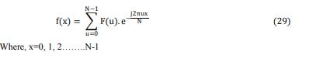

Where, x=0, 1, 2……..N-1





|  |  |
| --- | --- |
|  |  |
|  | 25 |





**(b) The Two Dimensional DFT**

Discrete Fourier Transformation of a function (image) f(x, y) of size M X N is specified by the equation,



For u=0, 1, 2 …M-1 and v=0, 1, 2……………N-1

The inverse DFT is obtained with the formula



Where x=0, 1, 2…..M-1 and y=0, 1, 2……N-1

**3.2.2 Walsh Transform**

It is a real transform consist series expansion for basic functions whose values are +1 or - 1 hence, it requires less computer memory than Fourier transform. Walsh transformation is mainly used in multiplexing, in which several data is simultaneously transmitted without the need of high energy packing capability.

**(a) One dimensional Walsh Transform**

The one dimensional Walsh transformation of a function f(x) is denoted by WT (u) and it is calculated using the formula,



Where, g(x, u) is the 1-D forward Walsh kernel and it is given by,



bit in the binary representation of z.

Inverse 1D Walsh Transform is expressed as,



The 1-D Inverse Walsh kernel is given by,





|  |  |
| --- | --- |
|  |  |

26



**(b) Two-Dimensional Walsh transform**

The 2-D Walsh transform is separable and symmetric. Hence, it is obtained by sequence of two one dimensional Walsh transforms. It is in the form of square waves and implemented more efficiently in a digital environment than the exponential basis functions of Fourier transform. Forward Walsh Transform is obtained by straight modification of FFT which uses successive doubling method.



Where, 2-D forward Walsh kernel g x, y, u, v is given by,



Where, 2-D inverse Walsh kernel h x, y, u, v is given by,



**3.2.3 The HADAMARD Transform**

HADAMARD transform is well suited for digital signal processing because the basic vectors of this transform take only the values +1 and -1. Therefore no multiplications are required in the transform calculation. It is real, symmetric and orthogonal transform which reduce number of additions and subtractions from N2 to Nlog2N. Recursive relation is an important property in which HADAMARD matrix of any size is computed from the small initial HADAMARD matrix. This transform is widely applied in the areas such as image compression, filtering and design.

**(a) The one dimensional HADAMARD Transform**

The 1-D forward HADAMARD transform is calculated using the formula,



For u=0….N-1 and



is the 1-D forward HADAMARD Kernel, N=2n , bx(z) − x th bit in the binary representation of z

The inverse HADAMARD transform is obtained by the formula,





|  |  |
| --- | --- |
|  |  |

27





Where x=0, 1…N-1 and h (x, u) = is 1-D inverse HADAMARD kernel.

**(b) The two dimensional HADAMARD Transform**

2-D HADAMARD transform is calculated using the formula,



Where,



Where, is the 2-D inverse HADAMARD kernel.

**3.2.4 The HAAR Transform**

The HAAR transform is real, orthogonal and fast transform on N X 1 vector. It can be implemented in O (N) operations. The basic vectors of HAAR matrix are sequentially ordered and used for image edge extraction. This transform exhibit poor energy compaction for images therefore it is not much useful in practice.

**3.2.5 The SLANT Transform**

SLANT transform is developed for monochrome or color image coding. Quality of an image coded by SLANT transform is higher than other unitary transform coded images. It is real, orthogonal and fast transforms which can be implemented in O (Nlog2N) operations on an N X 1 vector. Even though it has better energy compaction property than HAAR transform it is not used in practice.

**3.2.6 KARHUNEN LOEVE (KL) or HOTELLING Transform**

The KL transform or HOTELLING transform is also known as eigenvector transform or method of principal components or Discrete KL transform. It is based on the statistical properties of vector representation. It is very important tool used to evaluate performance and finding performance bounds in image data.

All transformations discussed in the above section have low energy compaction, de-decorrelation property which leads the possibility for redundant data and bundle of energy is associated with many coefficients.





|  |  |
| --- | --- |
|  |  |

28





**3.3 Discrete Cosine Transform (DCT)**

DCT is the best suitable method to address various issues discussed in previous section. An interesting contribution in this research work is the design and development of new splicing detection method using DCT. The Discrete Cosine Transform or Cosine transform is a fast transform mainly used in image compression. This mathematical transformation technique used to transform the image from spatial domain to frequency domain and attempt to de-correlate the image data after each transform co-efficient are encoded independently. Since DCT kernels are separable and orthogonal the 2D forward and inverse transform can be computed by successive application of 1D-DCT algorithm.

DCT is directly obtained from FFT algorithm and the N x N DCT is very close to KL transform of first order stationary Markov sequence of length N.

**(a)One dimensional DCT**

The one dimensional DCT coefficients are calculated with the formula,



Where u=0, 1, 2…N-1 and

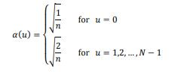

**(b)Two dimensional DCT**



Where u=0, 1, 2….N-1 and v=0, 1, 2…..N-1 and

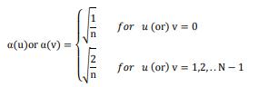



|  |  |
| --- | --- |
|  |  |

29





**3.4 DCT Based splicing Detection using sub block approach**

Architecture of proposed splicing detection method is shown in figure 3.1.

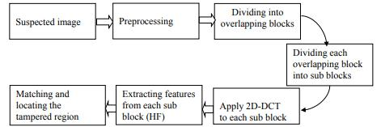

Figure 3.1: Frame work of proposed splicing detection algorithm

**Step 1: Pre-processing:** In the first step, the suspected input image I is checked as gray scale or colour image. The colour image is converted in to gray scale using the formula,

I1 = 0.299 R + 0.587 G + 0.114 B (42)

Where, R, G, and B are the three colour channels of suspected image.

**Step 2:** In order to ascertain the spliced region, the pre-processed input image is divided into overlapping blocks of fixed size b X b. Every neighbouring block will have one different row and column. Size of the overlapping blocks should not exceed the size Dividing into overlapping blocks Dividing each overlapping block into sub blocks Suspected image Matching and locating the spliced region Extracting features from each sub block (HF) Apply 2D-DCT to each sub block Pre-processing. 54 of the assumed spliced region thus the block size is optimized by performing series of experiments with different arbitrary spliced image regions and comparing exiting state of art methods. After series of experiments and comparisons block size is fixed as 8 X 8. Each overlapping blocks are represented by OBij where i and j indicates starting position of row and column of a particular block. Total number of overlapping blocks should not exceeds (M-b+1)(N-b+1). Where M, N denotes the size of the input image and b denotes the block size. This process is illustrated in figure 3.1.





|  |  |
| --- | --- |
|  |  |

30





**Step3:** Every overlapping blocks of size b X b is further divided into non-overlapping sub blocks of size NB X NB.

**Step 4:**Two Dimensional Discrete Cosine Transformations (2D-DCT) is applied to each non-overlapping sub block to extract the feature vector.

**Step 5:** Each sub blocks include both low and high frequency DCT coefficients. The high frequency DCT coefficients from each sub-blocks are extracted and arranged in a two dimensional matrix (MatHF). Each row of a matrix contains one block coefficients. Lexicographical sorting is applied to the matrix in order to compare the similarity between the blocks. As a result, similar rows are adjacent to each other which help to locate the spliced regions. Flowchart for lexicographical sorting is shown in figure 3.3.

**Step 6:** Every row in a two dimensional matrix M is compared with all other rows in order to match the similar image blocks. If two rows are similar the algorithm stores the position of identical rows and shift vector (SV) is calculated using the formula,

SV = (SV1, SV2) = (i1 - j1, i2 - j2) (43)





|  |  |
| --- | --- |
|  |  |

31





**CHAPTER 4**

**ANN-CLASSIFICATION**

In the proposed method of Artificial Neural Networks, there are two types of classifier has been performed such as Single Layer Artificial Neural Network Classifier and Optimized Multilayer with Back Propagation Algorithm for detecting the skin Melanocytes. These two methods are giving best result of Melanocytes classification. But the Optimized Multilayer with Back Propagation Algorithm is performed better - classification rate of result in Single Layer Artificial Neural Network Classifier.

**4.1 Reason for selecting Artificial Neural Networks**

In our research work, Artificial Neural Network (ANN) is choosing as a classifier for skin Melanocytes Classification because of its architecture. For the mathematical point of view Artificial Neural Network is a dynamic system and also it is able to model as a set of coupled differential equations. The major advantage of using Artificial Neural Networks is splicedistics such as Neurocomputing, Learning, Adaptability, Robustness, Fault tolerance, Asynchronous. The number of parameters is played a vital part of performance of ANN classifier. These parameters are increasing the percentage rate of accuracy. Basic parameters of ANN classifier is number of Layers involved in the networks, number of neurons performed for each layer, number of iteration, adaptability degree, selecting the non linearity function, learning algorithm and learning momentum, immunity of noise and so on...

**4.2 Working principles**

The network consists of collection nodes which are interconnected each other in the distributed manner that helps to obtain the output from the given inputs. The network works according to the concept of the brain functions and activities which is done by using three different layers such as input, hidden and output layer. The input layer obtains input from the previous feature extraction step, which is passed to the next hidden layer via the connected links

In addition to this network consists of collection of weights and bias value that helps to calculate the output value with effective manner. In hidden layer, the received inputs are process and fed into the output layer in which the output is calculated as,





|  |  |
| --- | --- |
|  |  |

32





At the time of output estimation process, the network trains the features using the training algorithm in this work, the Levenberg-Marquardt learning algorithm has been utilized for updating the weights and bias value which is done the equation



This training process produces the related output for all the features present in the neural networks. In the testing phase, the query template feature is compared to the output of the neural network, when it replies 0 the template is normal else it has been considered as the skin cancer related features. According to the concept of the traditional Artificial Neural Network working process in this work, Single Layer Artificial Neural Network and Multi Layer Neural Network has been used for making the effective skin cancer classification process.

**4.3 Delta Learning Rule**

One of the effective functions of the learning rule is minimizing the error rate while

examining the extracted features. The delta learning rule that mostly uses the gradient descent

learning process which helps to update the weights present in the Single Layer Artificial

Neural Networks. Then the delta rule of the neuron weights has been defined as,

According to the above process, the delta learning rule is applied to the network for

minimizing the error rate with effective manner. The minimized error rate also improves the

recognition rate while analyzing the extracted features. In our research work, Delta learning

rule has used in process of classification.

**4.4 Single Layer Artificial Neural Network Classifier**

The single layer neural network also called as the single layer perceptron that has single output nodes. The extracted features are fed into the input layer then the output value is calculated by multiplying the input value with weight, which is obtained the equation



The estimated output value is compared with the threshold value, if it is below to 0 or 1 then the activation function is applied to the network for continue the recognition process else it has been updated continuously for eliminating the error value. During this process, each neuron has been trained with the help of the delta rule for avoiding the error rate.





|  |  |
| --- | --- |
|  |  |





**4.5 Classification using Single Layer Artificial Neural Network Classifier**

According to this principle, first Artificial Neural Networks classifier designed named as Single Layer Artificial Neural Network. It consist a single hidden layer and using the

Tan h function as the learning function while examining the input values. Along with the learning function, the output value is calculated. During the net output calculation, the neural network is trained by using the Levenberg-Marquardt learning algorithm which updates the weights and bias as defined as,



This training process produces the related output for all the features present in the neural networks. In the testing phase, the query template feature is compared to the output of the neural network, when it replies 0 the template is normal or abnormal features. Thus the process successfully utilizes the learning momentum as 0.3 and the skin features are classified with minimum time and computational cost. At time of feature classification process, the network utilizes the Tan h as the learning function which is defined as Fig . The choice of learning momentum and also the activation function basically random selection only. In Single Layer Artificial Neural Network classifier has the two phases such as Training phase and the testing phase. In the time of preprocessing every images are employed the filtering, noise removing, edges are detected and finally the essential features are extracted and also the four optimum features are identified such as Asymmetry, Border Irregularity, Color change, Diameter These features are involved to the classification as the input value.

In the stage of training, the classifier trained with sample dataset. The training period classifier analyzes the feature of Melanocytes and makes a pattern for the testing. 85 The testing stage new input features are compared to the pattern and its produce the output. After the classification process established for Melanocytes, the classifier non- Melanoma represents.



|  |  |
| --- | --- |
|  |  |

34

**4.6. Multi-Layer Artificial Neural Network**

The Multi Layer Neural Network also called as the Multi Layer Perceptron which consists of three different layers namely, input layer, hidden layer and output layer. The input layer consumes the input from the feature extraction process which is passed to the hidden layer along with the weights value. Each node in the network uses the non-linear activation function while classifying the input values. Then the non-linear activation function successfully firing each neuron that helps to match the exact output. In addition to the activation function, the network uses the learning function for minimizing the error rate. Then the learning process is done by using the gradient descent value, which is calculated as,



Based on the equation, the weights values are continuously updated in the Multi Layer Network for minimizing the error rate with successful manner. The Multi Layer Neural Network examines the each input with effective way and provides the approximation solution for input. In addition to this, the effective learning rule process has been explained as follows for achieving the better results.





|  |  |
| --- | --- |
|  |  |

35





**4.6.1 Back Propagation Algorithm**

The Back Propagation Algorithm was developed in the year of 1974 and it has been usually used algorithm. BPN algorithm mainly divides the two sessions training session and testing session. Pair of patterns given in to the network, one is input pattern and another one is target pattern. The input patterns are the responsible for the output pattern and the error signal occurred will be by the difference between the actual 90 pattern and output pattern. Error signals are basically depend on the weights. If the weights get the new value then the error will be reduced. Before using the BPNN some of the parameters required such as set of training, input and target, learning rate, methods to be used for updating the weight, non linearity function, initial weight values. Generally sigmoid function used in the BPNN.

**4.6.2. Steps performed in Back propagation Algorithm** Step 1: Initialize the weights using small random values

Step 2: All the input neurons obtain the input signal and that signals are transmit to all hidden units.

Step 3: Every hidden neurons are sums its weighted input signals and applying the activation function then transfer that signal to output units.

Step4: Each output neurons sums its weighted input signals and relate its activation function to compute the output signal.

Step5: Each output neuron compares the target pattern corresponding to an input type, error value term is calculated as 

Step6: Weight and Bias of every output neuron updating.

Step 7: Examining the condition to terminate, when the error reduction and iteration count etc

**4.6.3 Informal Description of Back Propagation Algorithm**

The description of Back Propagation algorithm has seven major steps. These steps are involved the training phase. First the weight value should be initialize to the get input signals and transmitted to the hidden unit. The neurons are added to its weight and also applying to the activation function. After the activation function process 91 established the signals are transmitted to the output units. Each output neurons are added its weighted input signals and applies its activation function for calculating the output signals. Every output neuron compares to the target pattern corresponding to the input pattern and difference between the desired outputs and the target output value is referring as error value. Updating the weight of output neurons for reduce the error value and also get the target output. The iteration will be processed up to eradicate the error.





|  |  |
| --- | --- |
|  |  |

36





**4.7 Optimized Multilayer with Back Propagation Algorithm (OMLBPNN)**

The research purpose is efficiency improvement and also reduces the mis classification rate so that the new classifier has been designed. First the classifier Melanocytes. Back propagation algorithms are used for this classification. It will be modified with the help of different kinds of parameter such as activation function, learning rate, and count of hidden layers. The classifier alters by the number by steps. Each step has the improvement and also gives better result. Finally the output of the every stage has been compared and identified the better one. The modified classifier named as the Optimized Multi Layer with Back Propagation Algorithm is used for classifying the skin Melanocytes as well as to overcome the drawback of Single Layer Artificial Neural Network. It is trained with the help of the Delta learning rule along with one input layer, output layer, and hidden layers will be increased one by one. The layer utilizes the Taylor series for making the template examination process. Then the Taylor series defined as follow



T h e input layer receives the input from the trained features which has relevant weighted value and a bias value



After estimating the hidden value which is fed into the output layer for computing the final output that is calculated as ,



In the eqn (5.17), Based on the weighted value and bias value and final output is estimated with activation function. The first stage of our classifier designed with two hidden layers, learning momentum is 0.3 and the Tan h activation function. This stage of classifier gives somewhat improvement of accuracy. Second stage, need to test increasing the hidden layers. So the classifier gets the three hidden layers with same learning rate and activation function (0.3 and Tan h) as used in the second stage. After the alignment of classifier the features are fed in to the classifier and obtained the output at every time. Next the classifier increased the one more hidden layer i.e four hidden layer with same learning rate and activation function. In the time of increasing the hidden layer the performance of the classifier would be down compared to the three hidden layers. So, in that case get the conclude of hidden layers. As compared to four hidden layer three hidden only gives the better results. Now our classifier





|  |  |
| --- | --- |
|  |  |

37



fixed with the three hidden layer and here after the balance two parameters are only altered for getting the good results and 0.1. The randomized selection of learning momentum is involved to the classifier. Moreover decreasing range of learning momentum rate will increase the accuracy as well as number of iteration also increased. Based on the weighted value and bias value the final output is estimated and the sigmoid activation function is used for determining the skin cancer-related features. Then the sigmoid activation function is calculated as,

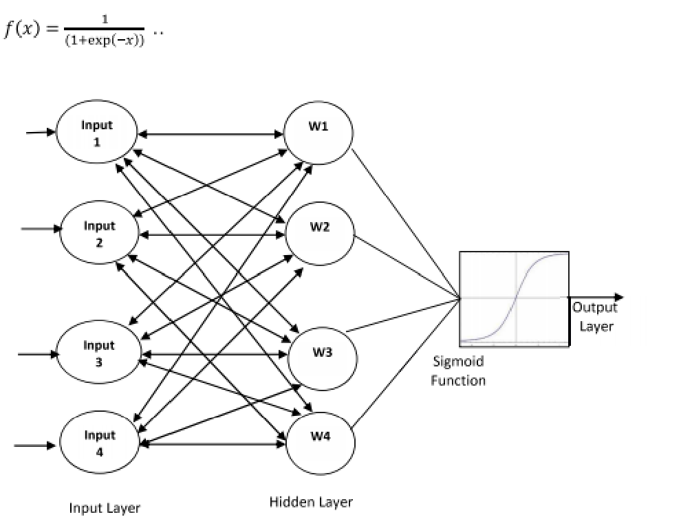

Figure 4.2. Structure of Optimized Multi Layer Back Propagation Neural Network

The Typical structure of Optimized Multi Layer with Back Propagation Algorithm is shown in the Fig 33. After computing the output value by using the sigmoid function which is compared with the target function. The matching process used to determine the error value then the error value is calculated as,



his process is repeated continuously until to eliminate the error value while matching the skin cancer with testing feature. The optimum features are fed into the classifier and the process of the classifier established finally the output is obtained. Based on the Optimized Multi Layer with Back Propagation Artificial Neural Network, the given input has been classified and the obtained.





|  |  |
| --- | --- |
|  |  |

38





**Preprocessing**

Preprocessing can basically depend on prerequisites and their corresponding approach in post processing operation. For example, normalization which is one of the elementary operations is used of resolution matching process. Assuming the given processing, the image size is considered as pixels and all images are in the similar proportion (for example ratio 4:3), it is very easy to find the smallest resolution of the given image and after that the large scale images to match the smallest image size. This process permits computing the different kinds of features for example lesion area coverage, lesion border, lesion dimensions. Additionally, the preprocessing process can use to normalize the other kind of parameters, for example, normalization of color components, color saturation normalization, color palette normalization and so on. It varies common process in preprocessing is known as color components normalization which is defined as histogram equalization. The image histogram is normally distributed differ color values in between extreme colors utilized in the palette. Considering the situation where the grayscale darkest points are not black and brightest points are not white, performing histogram equalization will restructure all the Red Green Blue (RGB) colors of the given image in a way which is obtained the brightest spot of the given image and it will black. Preprocessing has different kinds of steps such as image conversion and after that image enhancement. The image enhancement contains a several process such as edge detection, the noise removing and so on.

**Segmentation**

The segmentation is the most significant processes for examining the image properly since it affects the precious of the after following image processing steps. But, the segmentation is a very problematic process because of the high verities of color, sizes, lesion shapes with various kinds of skin sorts and textures. Additionally, some lesions have irregular boundaries and in another case, there is a smooth transition between the skin and the melanoma. The segmentation process addresses some issues, number of algorithms has been proposed with several researchers. They can be roughly categorized as region based, edge based, thresholding approaches.

**Artificial Neural Networks**

Inspired by the process of the human biological nervous system such as an Artificial Neural Networks (ANN) is a well-known information processing approach which comprises a huge number of greatly interconnected processing neurons and these kinds of neurons are work in a distributed manner to learn from the given input information, these neurons are





|  |  |
| --- | --- |
|  |  |

39





coordinating the internal processing and is to correctly optimize the final output. As countless algorithms have been implemented in the literature employing Neural Networks for medical image processing and analyzing the different kinds of medical images which processes are basically focused on computational intelligence with different kinds of neural networks, in this work using this method for skin medical image processing . The number of neural network applications in computer-aided diagnosis signified the computation intelligence mainstream in several of the medical imaging process. Their involvement and penetration are almost comprehensive for all medical issues because of the fact that neural network has the fundamental nature of adaptive learning process from given input information and utilizing a suitable learning content. Additionally, Neural Networks have the great optimizing capability in the relationship between outputs and input over the processing, training, distributed computing, which is direct to reliable solutions which are desired by different kinds of specifications, and medical diagnosis often based on the visual inspection, and medical imaging gives the most significant tool for facilitating such visualization and inspection. Another application of Artificial Neural Network process contains disease prediction, noise suppression, image enhancement, data compression and so on. More recently, the Artificial Neural Network application used for Magnetic Resonance Imaging (MRI) processing and also applied different simulation process using brain network. Because of the Artificial Neural Network similar nature of human neurons and Artificial Neural Network has been proved to be a very helpful for these new tasks.

**4.7.1. Basic Structure**

The fundamental structure of neurons can be modeled theoretically is presented in Fig where signified that the inputs to the neuron and here defined as the output. Each and every input is multiplied by their each weight , is related with each and every neuron and their sum is goes over the transfer function . As to the final outcome, the relationship between output and input can be defined



It has number of transfer functions which are available to process the biased and weighted inputs among which four fundamental transfer functions is extensively Adopted for medical image processing are shown in Fig 34 (a) Hard limiters, (b) Linear function, (c) Radial basic function and (d) Sigmoid function. Via a selection of proper transfer connection and





|  |  |
| --- | --- |
|  |  |

40





functions of neurons, different neural networks can be built to be trained for generating the particular outcome.

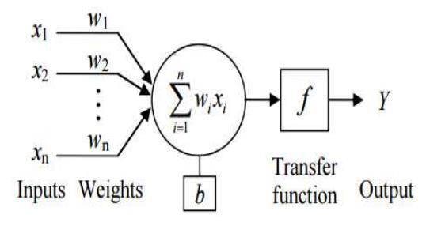

Figure 4.3 Modeling of Artificial Neural Networks

**(a) Hard Limiter**

The most of the classification patterns are used Hard Limiter function. This function is not differentiable for this reason it cannot be used for extension type of applications. The mathematical description is

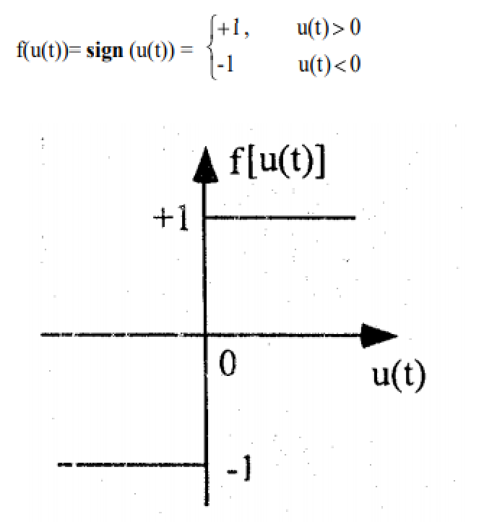

Figure 4.4 (a) Hard Limiter





|  |  |
| --- | --- |
|  |  |

41





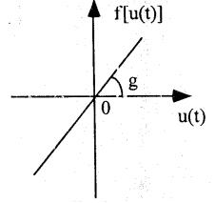

Figure 4.4 (b) Linear Function

Linear Function is a differentiable and it is generally used for output nodes of the networks.

The mathematical description is

f(u(t)) = g(u(t))

1. Radial Basis Function The Radial Basis function is the most commonly used function, and its mathematical description is

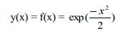

Range of the Radial Basis function signal is 0<y

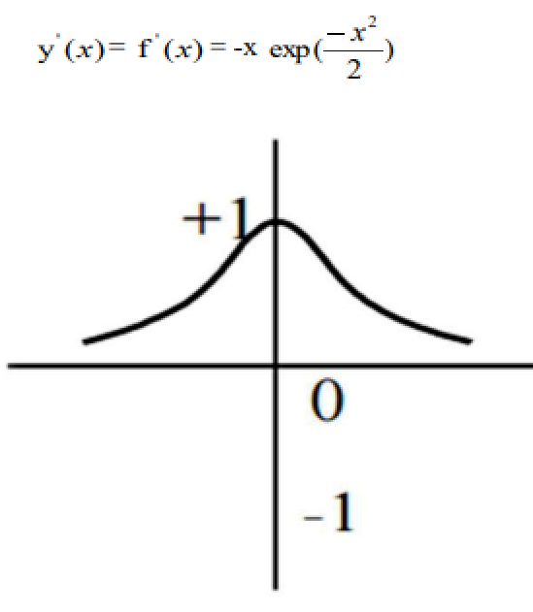

Figure 4.4 (c) Radial Basis Function





|  |  |
| --- | --- |
|  |  |

42

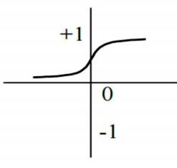



Figure 4.4 (d) Sigmoid Function

In Multi-Layered Feed Forward Neural Networks are usually used the Sigmoid activation function. It is also known as S shaped function. Its neurons are greater resemblance to the biological neurons and also give continuous values of output. Its mathematical description is



and its range of signal is 0<y

**4.8. Learning Rule**

The neural network learning paradigms in medical image processing typically contain unsupervised and supervised learning approach.

**4.8.1. Supervised Learning Approach**

The supervised learning approach is the simplest formalization about exsupervised samples. However, in supervised learning, the learner (normally, an algorithm) is learning given with two sets of data such as test set and training set. The idea is forgiven appropriate operation from a given set of labeled examples in the training set. Therefore, it can use for recognize the unlabeled examples in the given test set with the greatest possible accuracy. The main aim of this learner is to create a proper procedure, a program or a rule that classifies new examples (in the given test set) examining samples it has been giving have a class label. There are countless different methods that attempt to create the best possible approach of categorizing samples of the given test set by utilizing the data given in the already given training set.

**4.8.2. Unsupervised Learning Approach**

The unsupervised learning, the training data set does not contain any target information. Typically a function is described that measures the accuracy or suitability of the network. This particular function, often defined as a cost function, is considered normal and





|  |  |
| --- | --- |
|  |  |

43





application uses both outputs of the network and input of the network to generate a cost for the present network configuration. Typically the aim of unsupervised learning is to maximize or minimize the cost for all input vectors in the given training set.

**4.9 Feed-Forward Neural Network**

The Feed-Forward Neural Network (FFNN) is one of the well-known biologically inspired classification procedures. It comprises of a (possibly huge) number of the simple neuron for example processing units which are structured in layers. Each and every unit in the layer is linked to each and every unit in the previous layer. The layer connections are not all equal; each and every connection may have a weight or strength where the links between the units do not form a directed cycle.

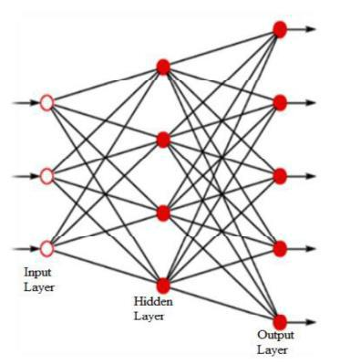

Figure 4.5: Feed-Forward Neural Networks

Often the units in the Neural Network are also named as node here the recurrent neural network differs from each other. The data enters at the inputs and passes over the network is processed in layer by layer, until it arrives at the proper outputs. At the time of normal process which is act as the classifier, there is no feedback between other layers. During normal operation, that is when it acts as a classifier, there is no feedback between layers

**4.10 Feed Backward Neural Networks**

Feed Backward Neural Network that helps to recognize the error rate while analyzing the optimized solution for particular user request which is done by using the appropriate





|  |  |
| --- | --- |
|  |  |

44





input, weights and learning process [16]. It is one of the supervised learning network that generalized by using the delta learning rule as the learning function

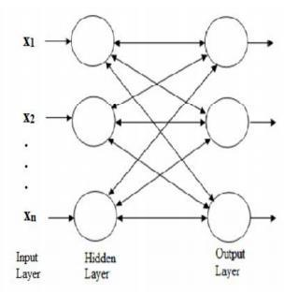

Figure 4.6: Back Propagation Neural Networks

The general structure of the Feed Backward Neural Network is shown in Fig 40. According to the figure the network has several layers such as input layer, hidden layers and output layer. Each layer consumes particular input from previous layer for recognizing the output class. In addition to this, the network uses the error back propagation process for reducing the mis-classification error rate. The network works in two phases such as propagation and weight updating process. In the propagation phase, the output value is calculated along with the error rate, the error rate is estimated.



In the eqn (1.7) E represented as the error rate, t is the random weight value and y denoted as the output value of the phase. The output has been computed using the weights and input value as follows,



If the computed error rate is more, then it has been propagated to the previous stage for continue the same process else, the output activation function is applied to estimate the output value. Then the net output values is estimated as follows,





|  |  |
| --- | --- |
|  |  |

45





If the error has been propagated to the previous stage, the weights and bias value has been updated for rectifying the network function. The updating process is done by using the delta learning rule which is explained. This process is repeated continuously for eliminating the error rate as well as recognizing the optimal solution with effective manner.





|  |  |
| --- | --- |
|  |  |

46





**CHAPTER 5**

**PROPOSED METHOD**

To improve the splicing detection rate and accuracy with state of art techniques, all the local features (color, texture, and shape) are optimized to construct the feature vector due to their richness in the content information. The proposed optimized splicing detection system framework is shown in Fig.1. All the color images including the query image are converted into HSV color space. The Hue and Value components are quantized to appropriate levels to extract the maximum color information from the image. Here, the Hue and Value are quantized to 18/36 and 10/20 levels respectively and corresponding histograms are constructed. The quantization level 18 makes the Hue divided into 20 parts where each bin in the H- histogram represents 200 ranges of colors and quantization level 36 makes Hue divided into 10 parts where each bin in the H-histogram represents 100 ranges of colors. More no.of bins in the histogram provides annoying discrimination in between the relative intensity and brightness of pixels. In this thesis maximum no. of bins used for H-histogram is 18 and S-histogram is 10. To extract the texture features, LBP is applied on the Value component of HSV color space to extract the texture features and build the histogram for it individually. The shape features extracted from the grayscale image, which is a converted version of the original RGB image. The LZM (Lower order Zernike Moment) technique is used to extract the shape features for the order n=5 and constructed a vector for each image. All the individual histograms on H,S,V histograms and LZM vector are combined to construct the feature vector and similarity metric is applied to retrieve the similar images.

**HSV Color Space**

Generally, images are three types in nature: Binary, Gray scale and Color. The binary image, which consists only two pixel intensities of white and black. The gray scale image, which contains a particular range of intensities in only one band. The last color image, which has three bands: Red, Green and Blue and each band has a particular range of intensities. The natural color images are known as RGB images, which contain three color bands i.e., red, green and blue. These three color bands can give only color information, not of color intensity information. Therefore, RGB color space not suitable for computer vision applications. To overcome the above problem HSV (Hue, Saturation and Value) color space is used which gives the color, brightness and intensity information respectively. Hue gives color information in terms of an angle from 0 0 to 3600 , and each degree represents a unique





|  |  |
| --- | --- |
|  |  |

47





color. Saturation ranges 0 to 1, and these values change from low to high when the intensity of color increases. Value also ranges 0 to 1. The distributions of pixel intensities for RGB and HSV color model shown in Fig.1.2. HSV color space provides the wide information about color ranges and their intensities. In the proposed method appropriate quantization levels (i.e.,18&10) has been taken on Hue and Saturation components for better results. More quantization levels make undesirable discriminations in between pixel intensities and brightness.

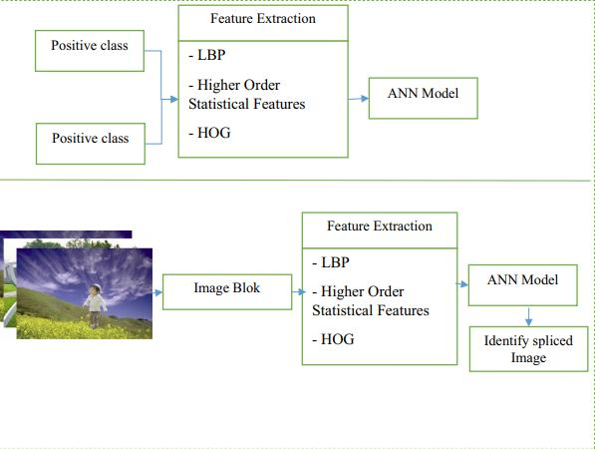

Fig. 5.1 The overall research framework of the splicing image forgery identification **MULTI-SCALE LBP (MSLBP)**

LBP finds the relation between the center pixel and surrounding eight neighbourhood pixels by comparing intensity values. In the continuation of LBP, a new approach for texture feature extraction entitled local maximum edge binary pattern (MSLBP). It captures edge information for each pixel with the help of eight surrounding pixels. For a center pixel and corresponding eight neighborpixels, MSLBP calculation procedure explained in the following steps:





|  |  |
| --- | --- |
|  |  |

48

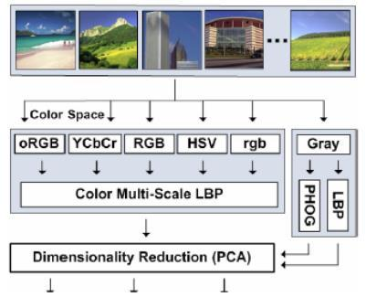



Fig. 5.2 The multi-scale LBP operator

**Step1**: Calculate the local difference di between neighbour pixel Pi and center pixel Pc for an image Im..



**Step2:** Sort the magnitudes of differences irrespective of the sign.



Where computes the maximum value in the array I. Sort is the function where it sorts the array in descending order irrespective of the magnitude of I.

Step3: Assign the binary label to each local difference according to its sign



Where f(x) is defined in the edge is positive assign 1 for this center pixel otherwise 0.



Step4: Repeat steps 1to 3 for all the pixels in 3x3 pattern and computes the edges. MSLBP defined as



After the calculations of MSLBP, the entire image is represented by constructing a histogram based on





|  |  |
| --- | --- |
|  |  |

49





Here, the image size is mxn.

**COLOR MULTI SCALE LBP(CMS-LBP)**

In this chapter, a novel approach for texture feature extraction local quantized edge binary pattern (CMS-LBP) has been proposed. The CMS-LBP expands and collects the relative information of center pixel towards its directional neighbours. This method has been proposed based on the local quantized pattern (LQP) and local maximum edge binary pattern (LMEBP). The LQP forms a geometric structure for a center pixel in the directions of Horizontal, Vertical, Diagonal, and Anti-diagonal. The proposed method applies the combination of LQP and LMEBP to extract texture features on the Value space of the HSV color model and color features extracted from Hue and Saturation components. In this algorithm, each pixel in the image will get sixteen edges that mean eight edges more as compared to the LMEBP. The other eight edges are calculated by including relative information of one pixel from every direction (i.e., ±00 , ±450 , ±900 , ±1350 ) of the center pixel of the LQP structure. Extraction of more relative information for each and every pixel from its neighbourhood helps in finding the similarities of different structures because the texture is a complex visual pattern which is formed by many different entities. The proposed method builds histograms individually on H, S and V components using the color histogram and CMS-LBP for color and texture features respectively. All these histograms are concatenated to construct a feature vector for all databases and query images. Finally, based on the analysis of similarity metric values images are retrieved and indexed.

The block diagram of new approach for color and texture feature extraction for efficient image retrieval is shown in Fig.4.1. The proposed method has been taken the HSV color model due its descriptive nature of brightness and intensity of color. The Hue (H) and Saturation (S) components are quantized to appropriate levels i.e H can quantized for 18/36 and S can quantized for 10/20 (as explained in Chapter-3) based on image size in the database. CMS-LBP applied on value space for texture features using LQP structure which is shown in Fig.. It has been observed that more quantization levels on H & S components give the more number of unwanted features. These features create the more distance between adjacent colours. Based on this criteria small size images undergo on 36 & 20 quantization levels The following steps demonstrate the procedure of proposed image retrieval system.





|  |  |
| --- | --- |
|  |  |

50





1. All the database images including query image are converted into HSV color space from RGB color space.
2. Based on the size of an image of a particular database appropriate quantization level has been chosen and the histograms are constructed for H & S components individually.
3. Take a 5x5 pattern which is shown in Fig.2, from a value space.
4. Compute local differences for center pixel.
5. Calculate 16-bit CMS-LBP pattern for a center pixel which has been taken.
6. Shift the center pixel and repeat step-4 &5 for all pixels in the image.
7. Construct histogram for all CMS-LBP patterns.
8. In order to build feature vector database concatenate all histograms (H, S, & V).
9. Apply similarity metric between query and database images using to retrieves and index the images.

**Feature Extraction using HOG**

HOG descriptor which employed here for the feature extraction. The two computation units considered here are the cells and blocks. Initially, the input image is divided into small regions known as cells. In every cell, the edge orientations or histogram of gradient directions is estimated for each pixel. After this, the normalization of all the histograms is done for enhancing the accuracy. The evaluation of normalization is done by measuring the intensity of a group of cells termed as blocks. The HOG feature extraction process is depicted in Figure 3.

Initially, the pre-processed image is split into g number of cells. The size of each cell is YX ; each cell comprises of X *Y number of pixels. Then, the histogram is computed for each cell. Following this, the cells are grouped for the generation of r number of blocks. Hence, the normalization is done to every image block. In Figure 5.3, if the size Pre-processed Image Block partitioning Histogram Gradient Computation Gradient Vote Feature vector Normalization Block 96 of each cell is 44 size, then, the size of the block is represented as 1616 . The HOG feature extraction process is elaborated in the upcoming steps.





|  |  |
| --- | --- |
|  |  |

51

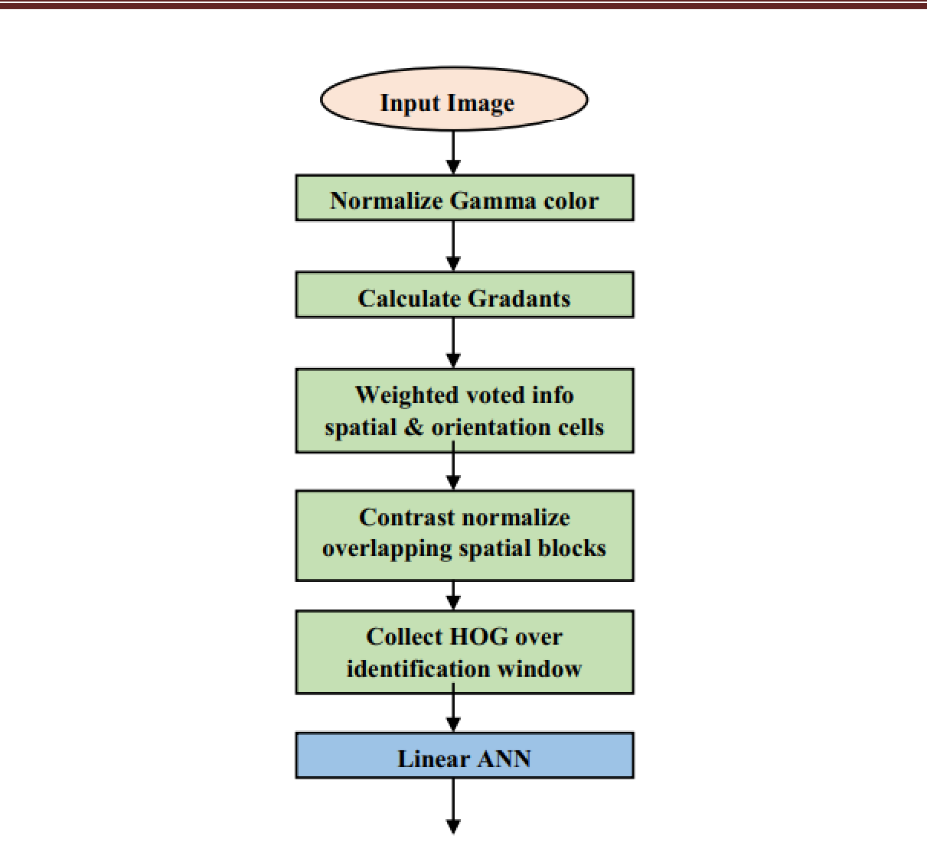

Fig.5.3: Splicing Image Forgery feature extraction process and object identification procedure

1. Gradient Estimation

The magnitude and orientation of each pixel (x, y) in the cell are estimated. Consider that the pixel is located at the (x, y) coordinate and its luminance value is indicated as l(x, y). Then, the pixel’s horizontal and vertical gradients are expressed as shown in equations (5.2) and (5.3) respectively,

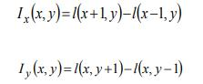

The magnitude m(x, y) developed by Olarik et al. (2015) is expressed as shown in equation (5.4),



Then, the orientation is estimated by using equation (5.5),





|  |  |
| --- | --- |
|  |  |

52

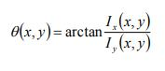



**Gradient Vote**

The gradient vote of an orientation histogram is validated regarding the gradient element centred within the cell. After this, the 97 determined orientation is spiltted into a number of bins. The equations formulated for incrementing the two bins a1 and a are expressed in the equations (5.6) and (5.7) accordingly,

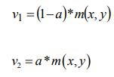

Here, the pixel weight is denoted as a and the magnitude is indicated as. , m x y the pixel weight is estimated using the below equation

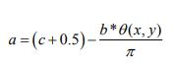

Here, the number of bins is denoted as b and the bin having the orientation  x y,  is denoted as c . Eventually, the normalization of each block is evaluated.

**Normalization Computation**

The normalization of each block consisting of number of histogram cells is estimated. The normalization expression for each block is shown in below equation (5.9)

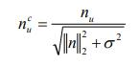

Here, the combined histogram cell’s block vector is indicated as u n and the constant, whose limit varies from one to bg, is denoted as u and the small constant for restricting the infinite constraint is notified as σ. Hence, the feature vector F is created by gathering the HOG descriptor feature from all the image blocks.





|  |  |
| --- | --- |
|  |  |

53

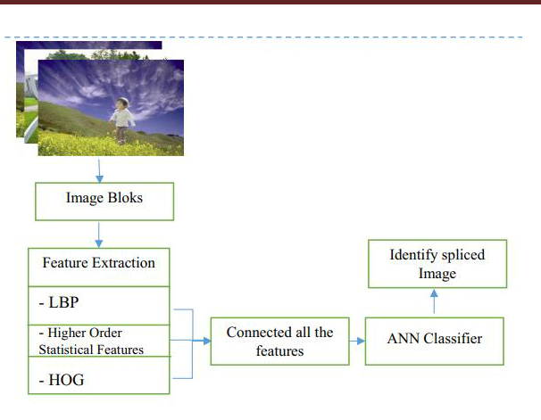

Fig. 5.4 The workflow of the feature-level fusion

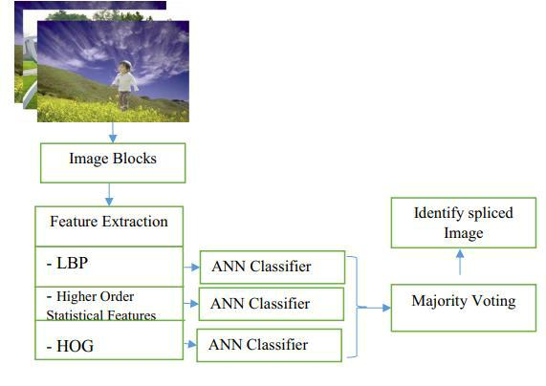

**Fig. 5.5 Framework to identify the spliced image using the majority voting**





|  |  |
| --- | --- |
|  |  |

54





**Linear ANN**

The modelling of the proposed PHC is elucidated in this section. The extracted feature set is provided as an input to the proposed 70 hybrid classifier for performing the recognition of the spliced. The three main classification modules of the modelled classifier are the ANN classifier, DT classifier and the probabilistic model based classifier. The generated classes from the DT and ANN classifier are utilized by the probabilistic model based classifier. This hybrid classifier recognizes the optical spliced on the basis of the maximum posterior probability measure representing the spliced image.

The ANN classifier adopted here utilizes the FLM training algorithm developed by the integration of the firefly optimization algorithm with the LM algorithm. The detailed discussion on the series of steps adopted during the weight update in the FLM based ANFIS is already made in chapter 4. The spliced image’s feature vectors [f]mx F are classified into any one of the 62 classes. Each matrix formatted input feature vector comprises of the vector space values categorized into classes in accordance with the feature space splice distils. The generated classes are mentioned as the mutually exclusive labels. The NN classifier output for the n number of the input image is represented as equation (4.9),



Here, o is the output class, Output generated by the NN classifier is denoted as Co

The figure 5 performs the splice image detection using the fusion of features and applied to the ANN classification purpose. Figure 6 represents the individual ANN classification operation on different features, then depending upon the classification accuracy the majority voting operation will be performed and maximum accuracy features with results output as high accuracy spliced image.





|  |  |
| --- | --- |
|  |  |

55





**CHAPTER- 6**

**ABOUT PYTHON SOFTWARE**

**TOOL-PYTHON**

**Step-1: create new python project on Pycharm**



**We choose pure python**





|  |  |
| --- | --- |
|  |  |

56

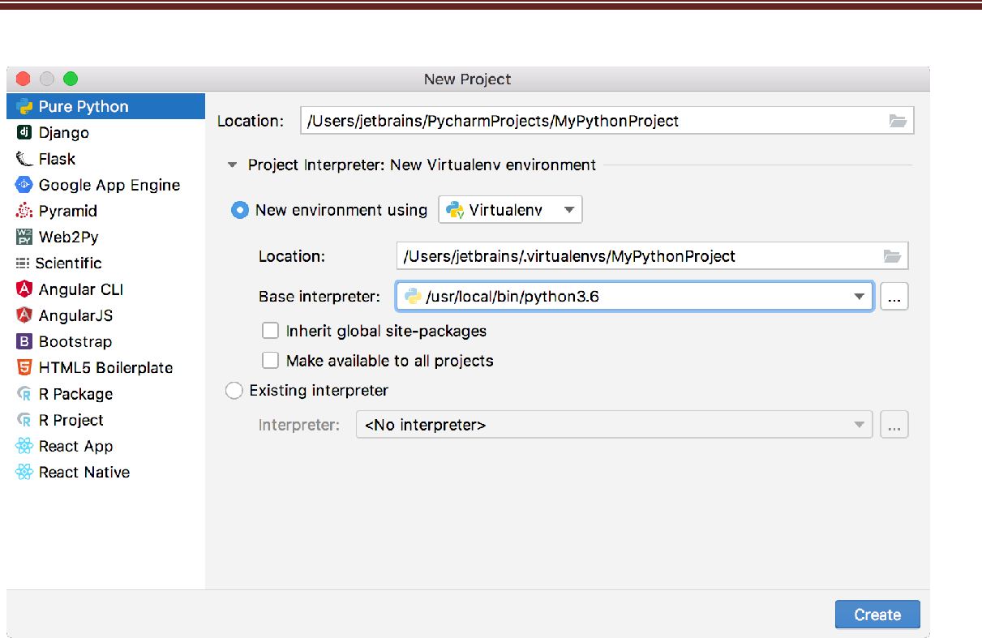

We can Choose project location by clicking button next to the **Location** field, and we can specify the directory for the project.

In the **Project Interpreter: New Virtualenv Environment** node and select u new virtual environment. choose **Virtualenv** tool, and we specify the location and base interpreter used for the new virtual environment. We can Select the two check boxes .

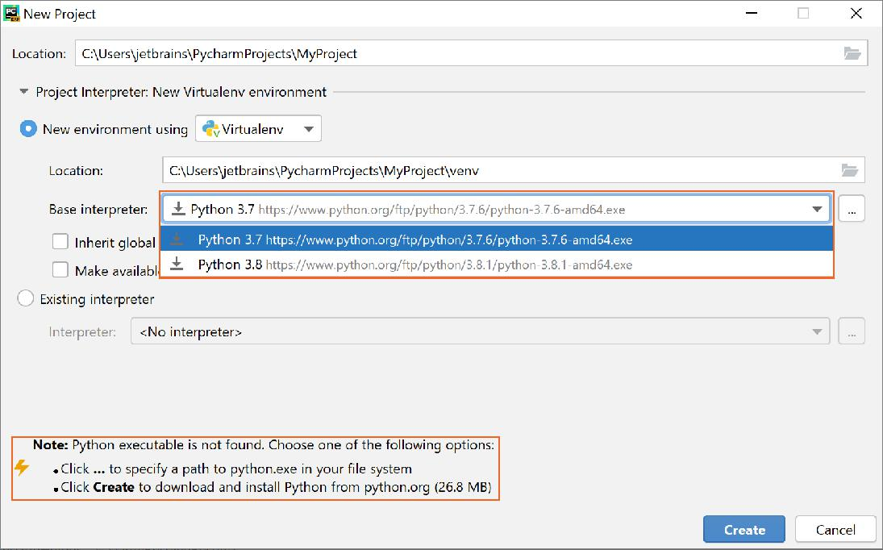

Click create button





57





**Step 2:Create python file:**

Select the **Project** tool window, then select **File ,**and then **New** from the main menu or press Alt+Insert .



Choose **Python file** from the popup, and then type the new file name.



It creates a new Python file and opens it for editing.





|  |  |
| --- | --- |
|  |  |

58





**Step3:Editing the source code**

If you want to create Python class. you just start typing it appears suggestion .



Choose class and type the class name we want. PyCharm informs about the missing colon,

and then expected indentation:









create function init: when you type opening brace, PyCharm creates the entire code construct

and provides proper indentation:



**Step 4:Run the application**

you see the popup menu of the available commands. We can Choose **Run** :

**Run or debug configuration:**

PyCharm creates a temporary *run/debug configuration* . first save the configuration: go to the run configuration dropdown on the top-right of the editor, and choose **Save configuration**.





|  |  |
| --- | --- |
|  |  |

60

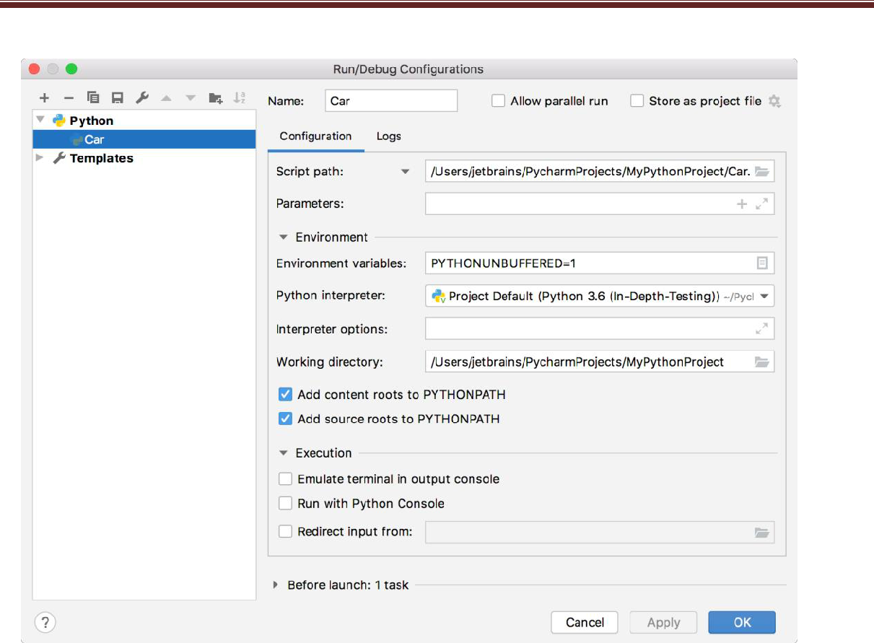

To Run configuration use the  button .

**Python console:**

It is using within PyCharm is to benefit from the main IDE features, such as code completion, code analysis, and quick fixes.

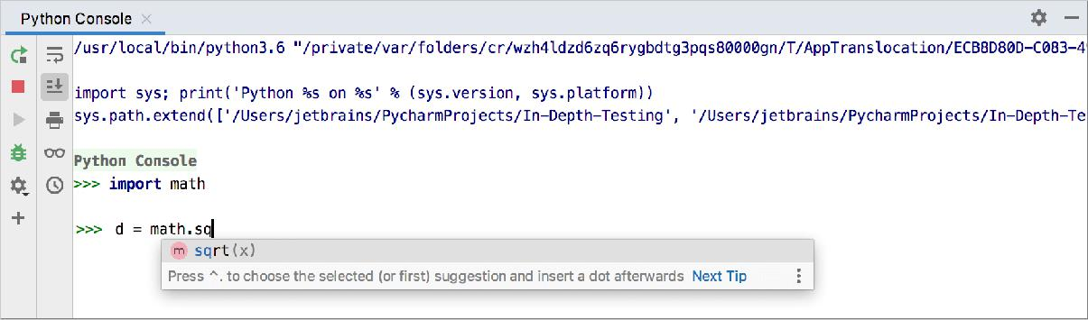

**Run source code from the editor in console:**

1. Open file in the editor, select a fragment of code to be executed.





|  |  |
| --- | --- |
|  |  |

61





1. From the context menu of selection, choose **Execute selection in console**, or press Alt+Shift+E:





|  |  |
| --- | --- |
|  |  |

62



**CHAPTER-7**

**SIMULATION RESULTS**

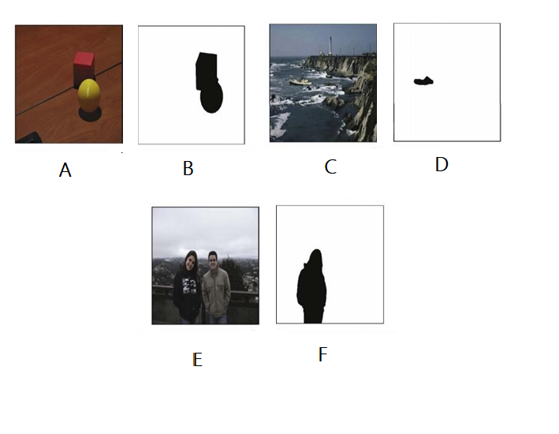

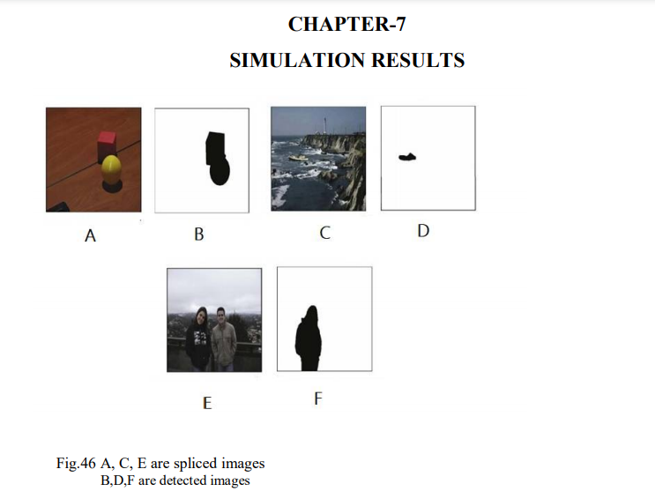



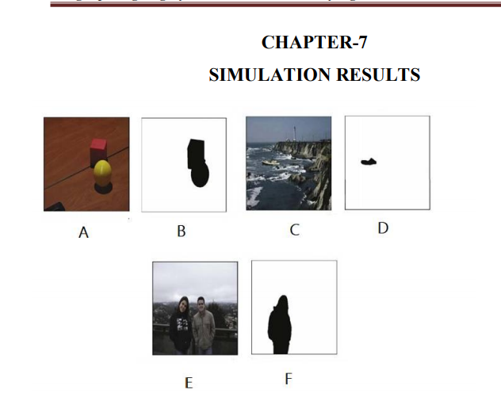

Fig. 7.1 (A), (C) & ( E) are spliced images ( B) ,(D) & (F) are detected regions

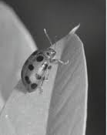 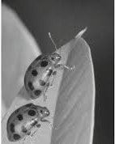 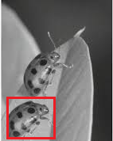

A B C

Fig.7.2 (A) Original image (B) tampered image (C) detection of tampered region



|  |  |
| --- | --- |
|  |  |
|  |  |
|  |  |
|  |  |
|  |  |
|  |  |

63





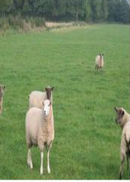

A B

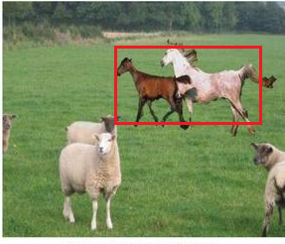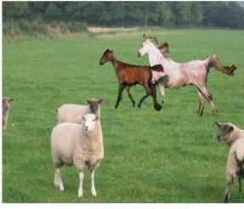

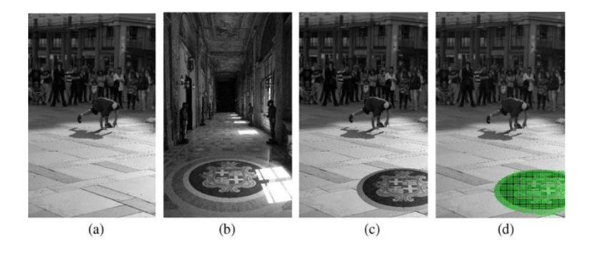 C D

Fig.7.3 (A) and (B) Original images (C) tampered image (D) detection of tampered region

Fig.7.4 (A) and (B) Original images (C) tampered image (D) detection of tampered region

64



**CHAPTER 8**

**CONCLUSION AND FUTURE WORK**

Digital image splicing detection is a process of detecting, storing, analysing and presenting evidence from the source. Spliced images will leads series of threats in image security as well as destroy some ones reputation in the society. Hence, development of an automatic splicing detection model becomes important to effectively analyse the trustworthiness of an image. Intrusive and non-intrusive are the two techniques used to authenticate image content. Developing an automatic non-intrusive splicing detection algorithm to ensure reliability of an image is most prominent research area in image processing. Image splicing detection has higher influence in different domains such as forensic investigation, law enforcement, insurance claim processing, scientific journals and wherever images are used as evidence. Discovering the spliced image region becomes critical task when it is distorted by various geometric and post processing operations.

In this research work importance of digital image splicing detection and its implementation issues have been discussed. Experimental analysis on various splicing detection methods are carried out and optimized nonintrusive image splicing detection model has been developed by using an efficient block and key point descriptors. Images are processed in spatial and frequency domains. Processing images in spatial domain incurred more computation and makes the image processing task a complex one. Hence, a new block based copy-move splicing detection approach has been developed by using

This method has lower computational complexity and high accuracy rate over the existing methods but not suitable for spatial feature based analysis. Hence, a new optimized wavelet based algorithm has been implemented with reduced multi dimensional scaling features to discover the spliced image regions which is blurred, brightness altered and colour reduced with different levels. Wavelet based method is inappropriate when the spliced region is rotated or scaled. Hence, as part of this research work, moment invariant based splicing detection method has been developed based on LBP and HOG features. Empirical outcomes demonstrate that the proposed method efficiently detects the spliced region even it is scaled, rotated, blurred or brightness adjusted. The above said methods make use of block based feature descriptors to discover the spliced image regions. However, Key point based descriptors plays a crucial role in analyzing the spliced region which is distorted by different geometric and post processing operations.





|  |  |
| --- | --- |
|  |  |

65



An efficient splicing detection algorithm has been developed based on ANFIS to discover simple and multiple spliced regions even after some geometric and image distortions. Results show that this method performs better than existing SIFT and SURF methods. Selection of optimum features from the extracted features is another significant phase in any splicing detection approach. Identifying these specific features will help to reduce the complexity of the detection algorithm. A novel splicing detection and localization algorithm based on optimized LBP and HOG features has been developed as part of this research work to discover the spliced image regions which is geometrically distorted, JPEG compressed, noise contaminated, blurred, brightness and color adjusted. Detection performance illustrate that this method outperforms existing state of art methods. Image splicing is another crucial image splicing method in which two or more image regions are combined together to form a composite image. An efficient method has been developed using wavelet based LBP and HOG features to classify the spliced image from the original image through ANFIS classifier. Empirical outcome demonstrate that this method perform well than existing methods by means of accuracy, specificity and sensitivity.

**Future Work**

Even though proposed methods are performing better splicing detection than existing methods still there are some constraints and limitations in the proposed algorithm. Illumination distortion is one of the bigger challenges in splicing detection. Proposed method shows accuracy up to 97% and still there is a need of developing a robust method to reduce false matches and improve the accuracy while detecting copy-move forgery. Image splicing creation and enhancement tools are already established however, better Non-intrusive splicing detection algorithms are mandatory in the field of image forensics analysis. Optimization of various input parameters used in the algorithms can be done to improve the accuracy of detection. Advanced machine learning approaches can be deployed to classify the spliced image. This splicing detection can be extended to audio and video splicing detection. Image retouching can also be addressed in future research.





|  |  |
| --- | --- |
|  |  |

66





**REFERENCES**

[1] H. Farid, “A Survey of Image Forgery Detection”, Signal Processing Magazine, vol.

26(2), pp: 16–25, 2009.

1. Gajanan K Birajdar, Vijay H Mankar, “Digital image forgery detection using passive techniques: A survey”, Digital Investigation, Vol.10 (1), pp: 226–245, Elsevier, 2013.
2. Luo Weiqi, Qu Zhenhua, Pan Feng, Huang Jiwu, “A survey of passive technology for digital image forensics”, Frontiers of Computer science, Vol.2 (1), pp: 1−11, 2007.
3. Tanzeela Qazi, Khizar Hayat, Samee U Khan, Sajjad A Madani, Imran A Khan, Joanna

Kołodziej, Hongxiang Li, Weiyao Lin, Kin Choong Yow, Cheng-Zhong Xu, “Survey on blind image forgery detection”, IET Image Processing, Vol.7(7), pp:1–11, 2013.

[5] V. Thirunavukkarsu, J. Satheesh Kumar, “Analysis of digital image forgery detection techniques”, International Conference on Convergence Technology, Vol.4 (1), pp: 1000– 1002, 2014.

1. V. Thirunavukkarsu, J. Satheesh Kumar, “Analysis of various noise models and filtering techniques used for image restoration”, IJRCSIT, Vol.3 (1), pp: 4–9, 2014.
2. C. Rey, J.L. Dugelay, “A survey of watermarking algorithms for image authentication”,

EURASIP Journal on applied Signal Processing, Vol.2 (6), pp: 613–621, 2002.

[8] Pointcheval, J.Stern, “Security arguments for digital signatures”, Journal cryptography, Vol.13 (3), pp: 361-396, 2000. [9] Thirunavukkarasu, J.Satheesh Kumar, “Intrusive and Non-Intrusive Techniques for Detecting Fake Images”, IJBI, Vol.3 (1), pp: 374 – 379, 2014.

[10] Ng, Chang, S.F.Lin, C. Y.Sun, “Passive-blind image forensics”, Multimedia Security Technologies for Digital Rights, Vol.15(1), pp:383-412, 2006.

1. Bayram S, Avcibas I, Sankur B, Memon N, “Image manipulation detection with binary similarity measures”, In IEEE Signal Processing Conference, pp:1-4, 2005.
2. Thirunavukkarasu V, Satheesh Kumar J, “Evolution of blind methods for image splicing detection-A review”, International Journal of Applied Engineering Research, Vol.9 (21), pp:

5069–76, 2014.

[13] Yu-feng Hsu, Shih-fu Chang, “Detecting Image Splicing using Geometry Invariants and Camera Characteristics Consistency”, ICME, pp: 549-552, 2012.

1. Lin, Zhouchen, “Detecting doctored images using camera response normality and consistency”, Computer Vision and Pattern Recognition, Vol. 1(1), pp: 1087-1092, 2005.





|  |  |
| --- | --- |
|  |  |

67





1. Hsu, Yu-Feng, Shih-Fu Chang, “Image splicing detection using camera response function consistency and automatic segmentation”, 2007 IEEE International Conference on

[16] Yu-Feng Hsu, Shih-Fu Chang, “Camera Response Functions for Image Forensics: An Automatic Algorithm for Splicing Detection”, IEEE Transactions on Information Forensics and Security, Vol. 5(4), pp: 816-825, 2010.

[17] Johnson M, Farid H, “Exposing digital forgeries through chromatic aberration”, In:

Proc.ACM Multimedia and security workshop, 2006.

1. IdoYerushalmy, Hagit Hel-Or, “Digital Image Forgery Detection Based on Lens and Sensor Aberration”, International journal of computer vision, Vol.9(2), pp:71–91, Springer, 2011.
2. Ahmet Emir Dirik, Nasir Memon, “Image Splicing Detection Based on

DemosicingArtifacts”, IEEE Transaction on Signal processing, Vol.1(1), pp: 1497-1500, 2009.

[20] Choi, Chang Hee, HaeYeoun Lee, Heung Kyu Lee, “Estimation of color modification in digital images by CFA pattern change”, Forensic science international, Vol. 226(1), pp: 94-105, 2013. Please purchase PDF Split-Mer

[21] Lu Li, JianruXue, Xiaofeng Wang, Lihua Tian, “A robust approach to detect digital forgeries by exploring correlation patterns”, Pattern Analysis and Applications, Vol.18(2), pp:351–365, Springer, 2013.

1. R. Gonzalez and R. Woods, 2002 “Digital Image Processing” 3rd Edn., Prentice Hall Publication, ISBN:9788120336407 [23] M.R.Banham, A.K.Katsaggelos, “Digital image

restoration”, IEEE Signal Processing Magazine, vol. 14, pp: 24-41, 1997.

1. Jain, Anil K, “Fundamentals of digital image processing”, Prentice-Hall, 1989.
2. C.L.Chan, A.K.Katsaggelos, A.V. Sahakian, “Image sequence filtering in

Quantumlimited noise with applications to low-dose fluoroscopy”, IEEE Transaction on Medical Imaging, Vol. 12, pp. 610-621, 1993.

1. Kodogiannis V. S, Maria Boulougoura, “An adaptive neurofuzzy approach for the diagnosis in wireless capsule endoscopy imaging”, International Journal of Information Technology, Vol. 13(1),pp: 46-56,2007.
2. Chen, Nguyen Minh Thanhand Mu-Song, “Image de-noising using adaptive neuro-fuzzy

system”, IAENG International Journal of Applied Mathematics, Vol.36(1), pp:1-7, 2007.





|  |  |
| --- | --- |
|  |  |

68





1. M.Tulin Yildirim, AlperBasturk, EminYuksel, “Impulse Noise Removal from Digital

Images by a Detail preserving Filter based on Type-2 Fuzzy Logic”, IEEE Transactions on Fuzzy systems, Vol. 16(4), pp:920-928, 2008.

1. Fei Peng, Yun-yingNie, Min Long, “A complete passive blind image copy-move

forensics scheme based on compound statistics features”, Forensic Science International, Vol.212(1), pp:21-25, Elsevier, 2011.

[30] Battiato S, G. Puglisi, R. Rizzo, A. Bosco, A. R. Bruna, “Image sensor noise profiling by voting based curve fitting”, In IS&T/SPIE Electronic Imaging, pp: 90230-90230, 2014.





|  |  |
| --- | --- |
|  |  |

69